Tour ID: 262699  
Tour Name: Westfjords of Iceland - 8 days

Tour destinations: ['Keflavik', 'Reykjavik', 'Grábrók Volcano', 'Hnjotur', 'Latrabjarg', 'Dynjandi', 'Isafjordur', 'Flateyri', 'Hraunfossar']

Tour destinations images:

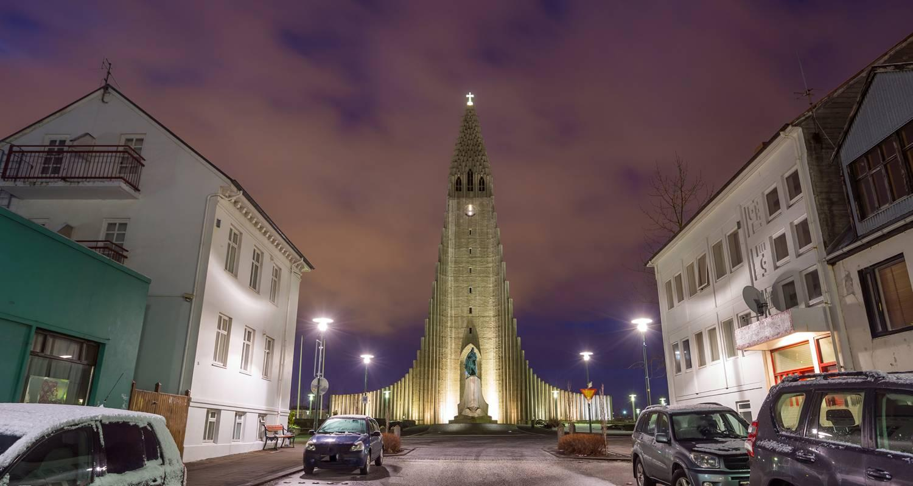

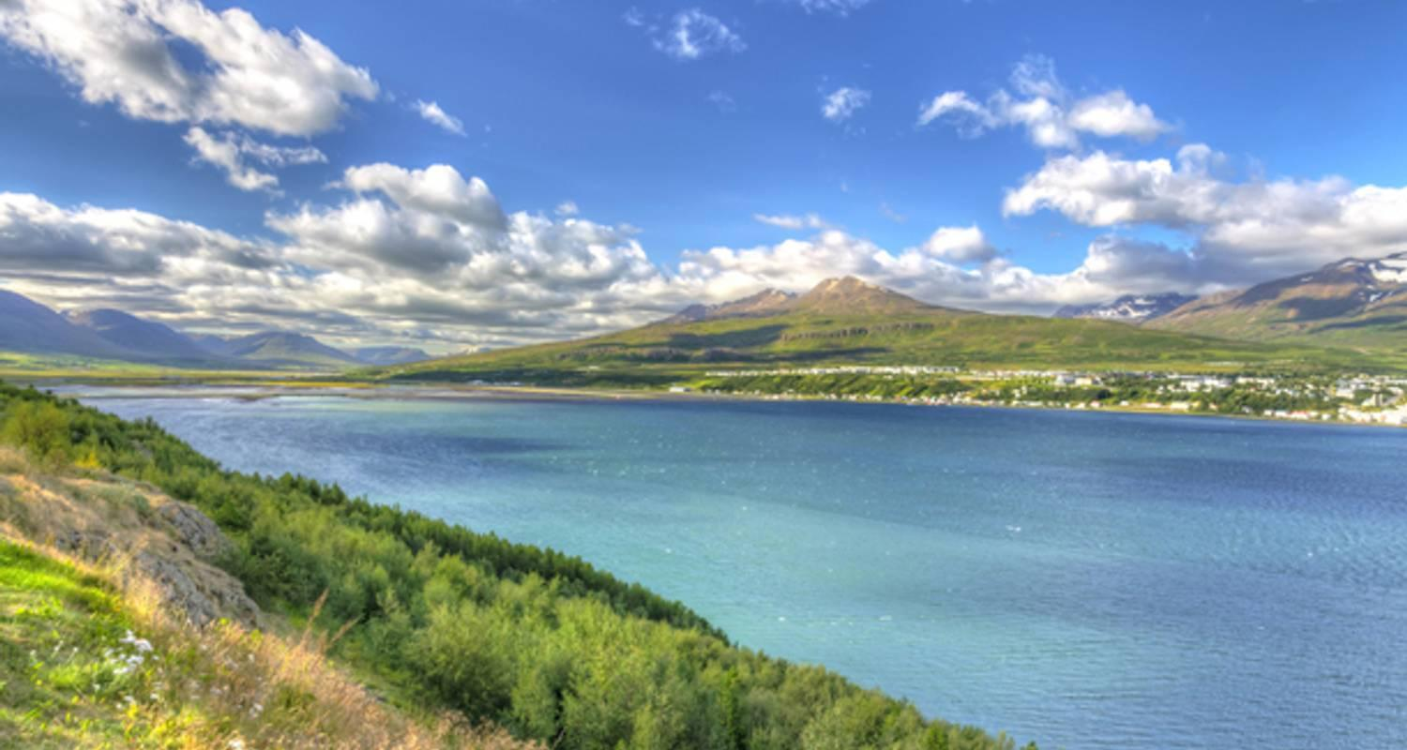

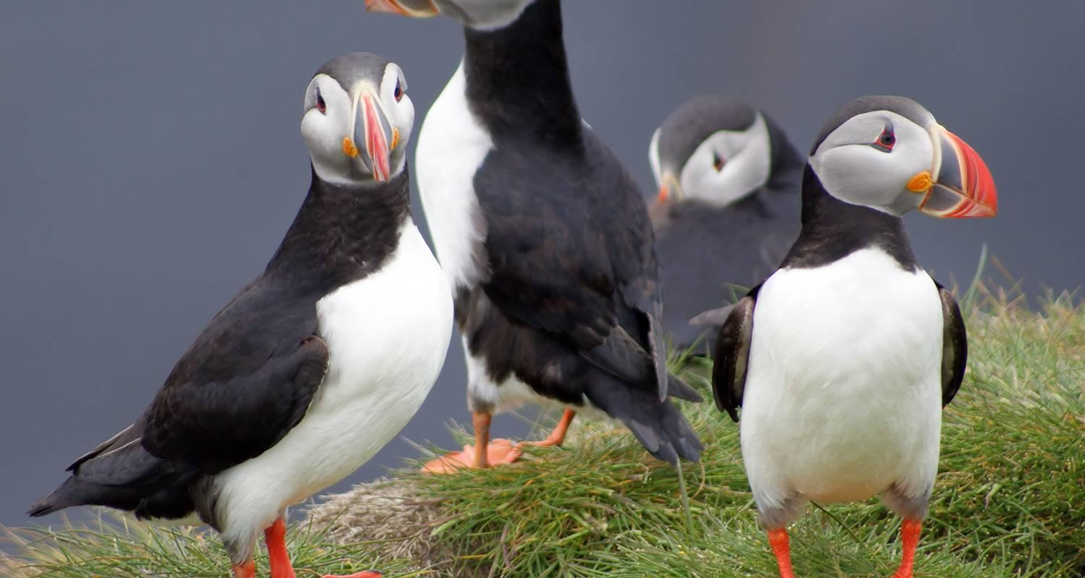

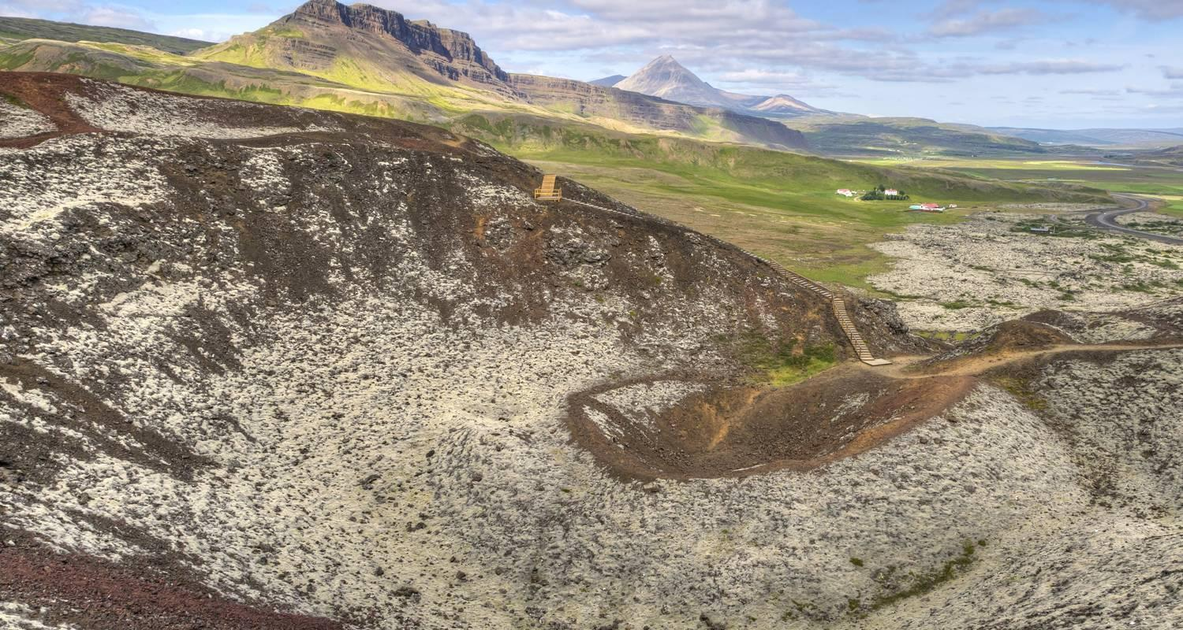

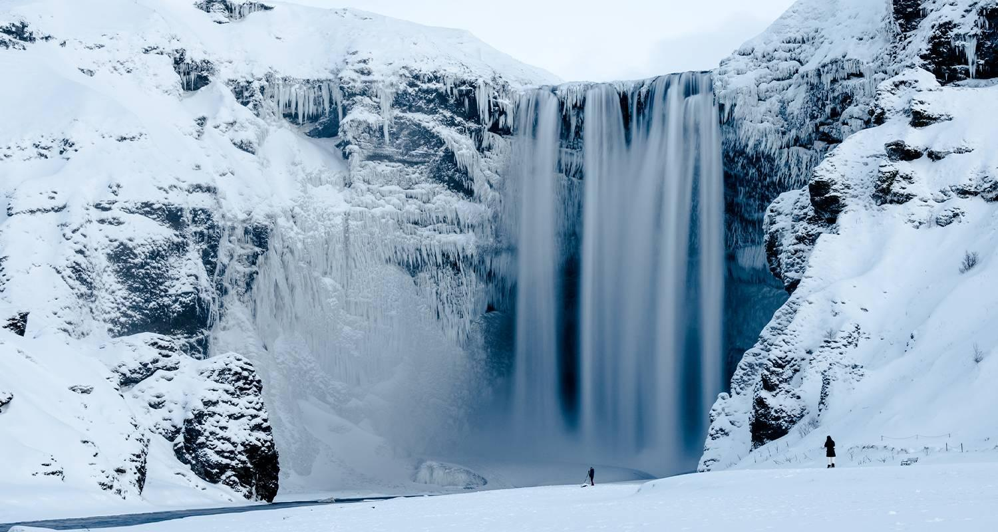

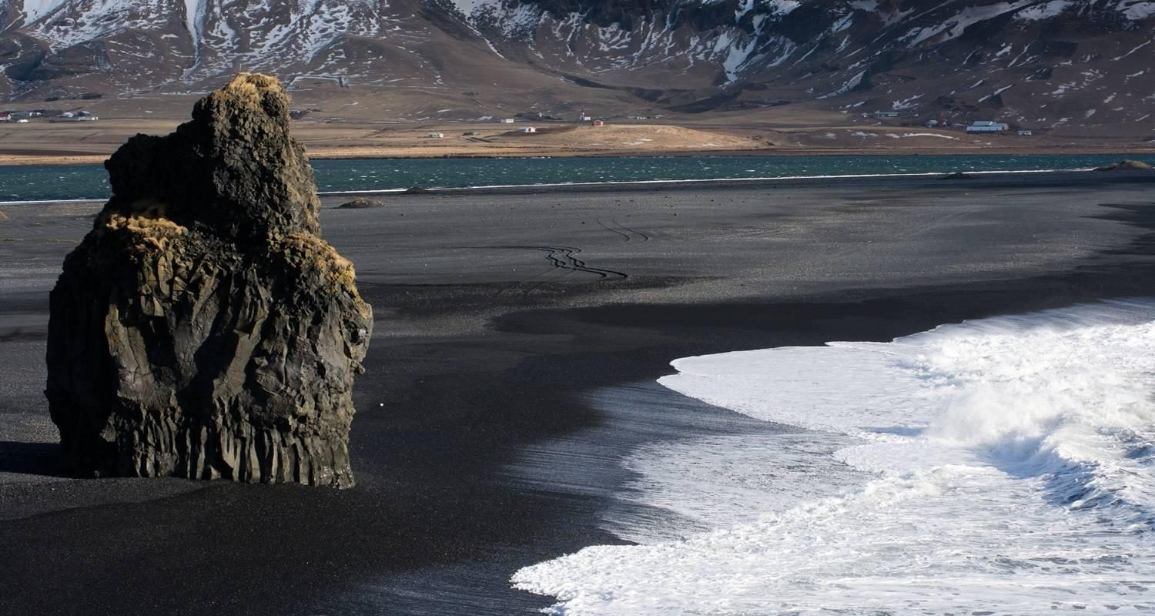

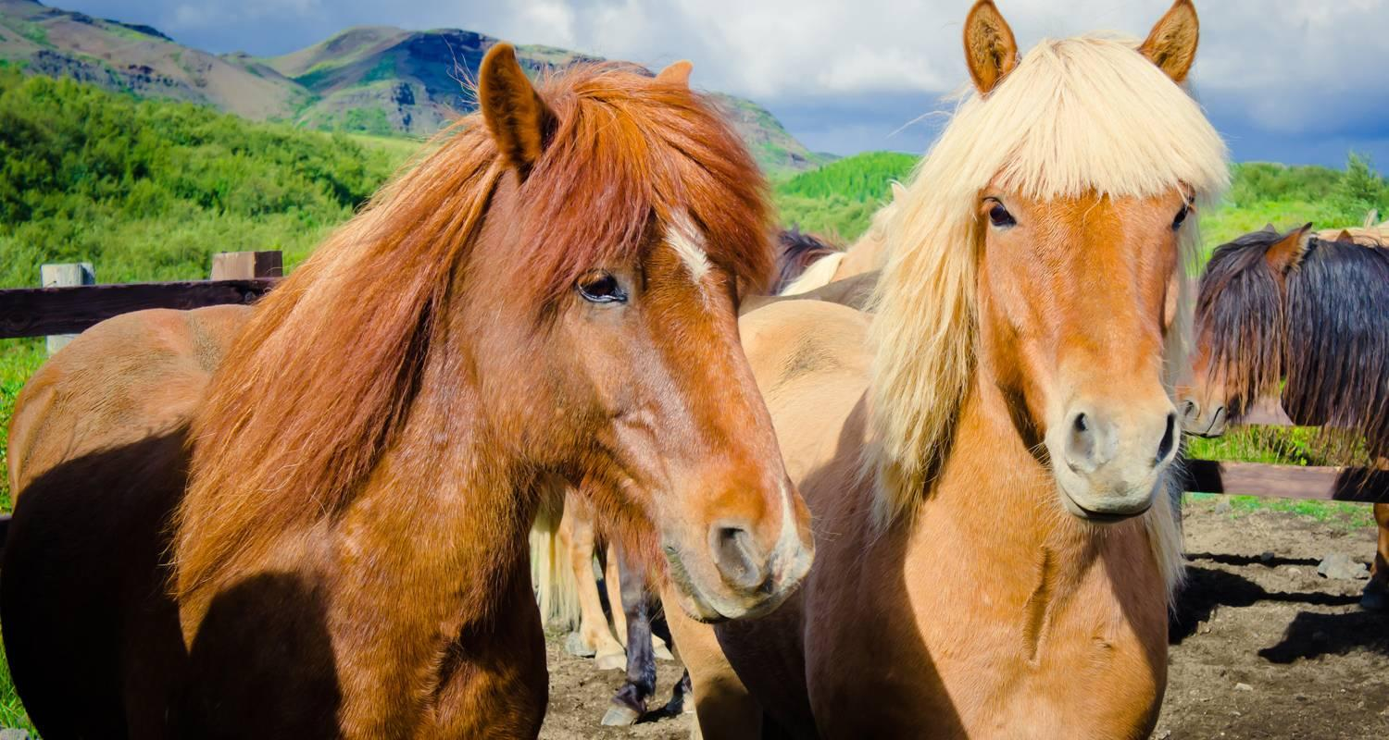

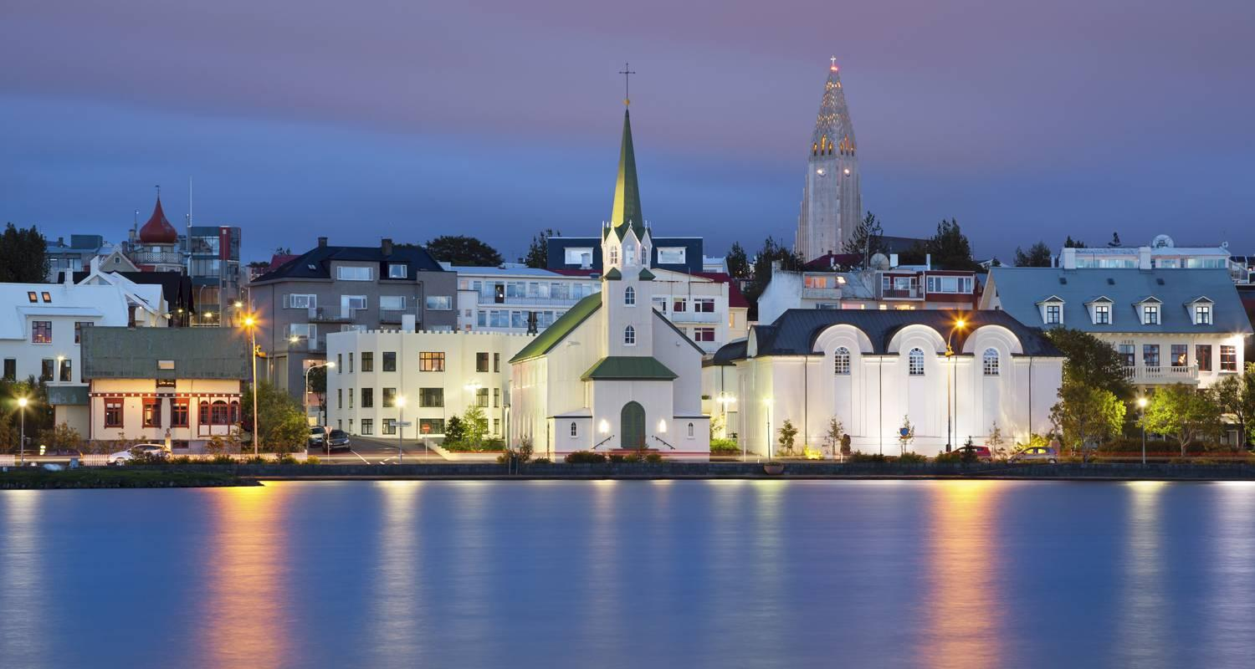

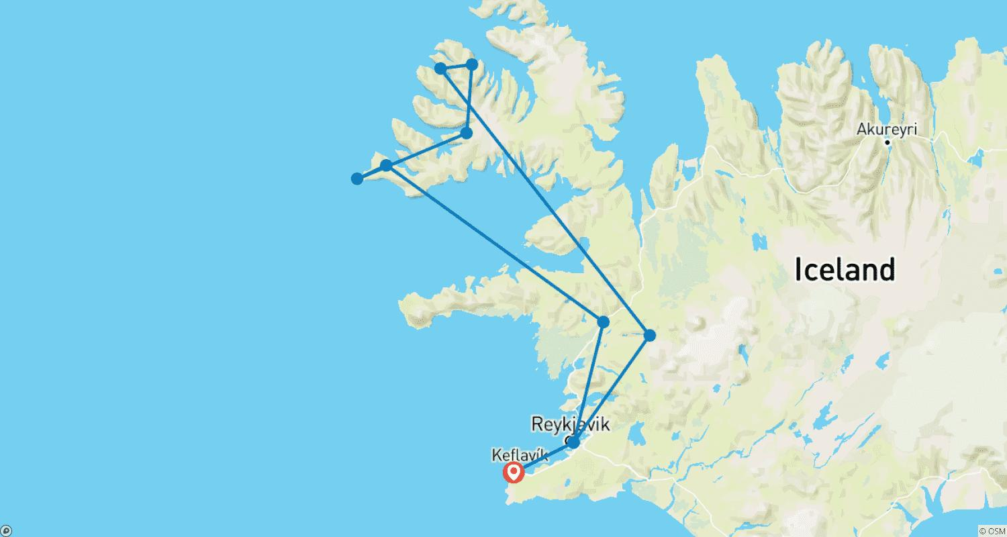

Tour ID: 263641  
Tour Name: 【Iceland & Suez Canal】The Full Northern Light Escape and Ancient Wonders

Tour destinations: ['Reykjavik', 'Vatnajokull National Park', 'Barcelona', 'Marseille', 'Civitavecchia', 'Alexandria', 'Suez', 'Aqaba', 'Muscat', 'Doha', 'Dubai']

Tour destinations images:

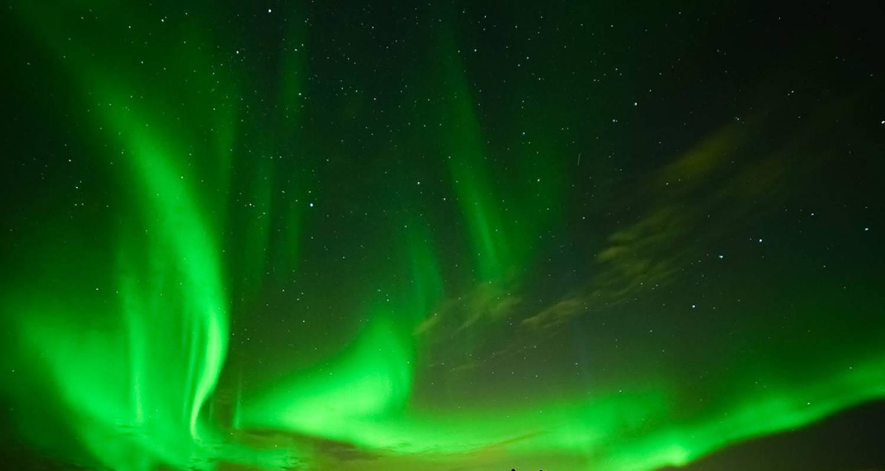

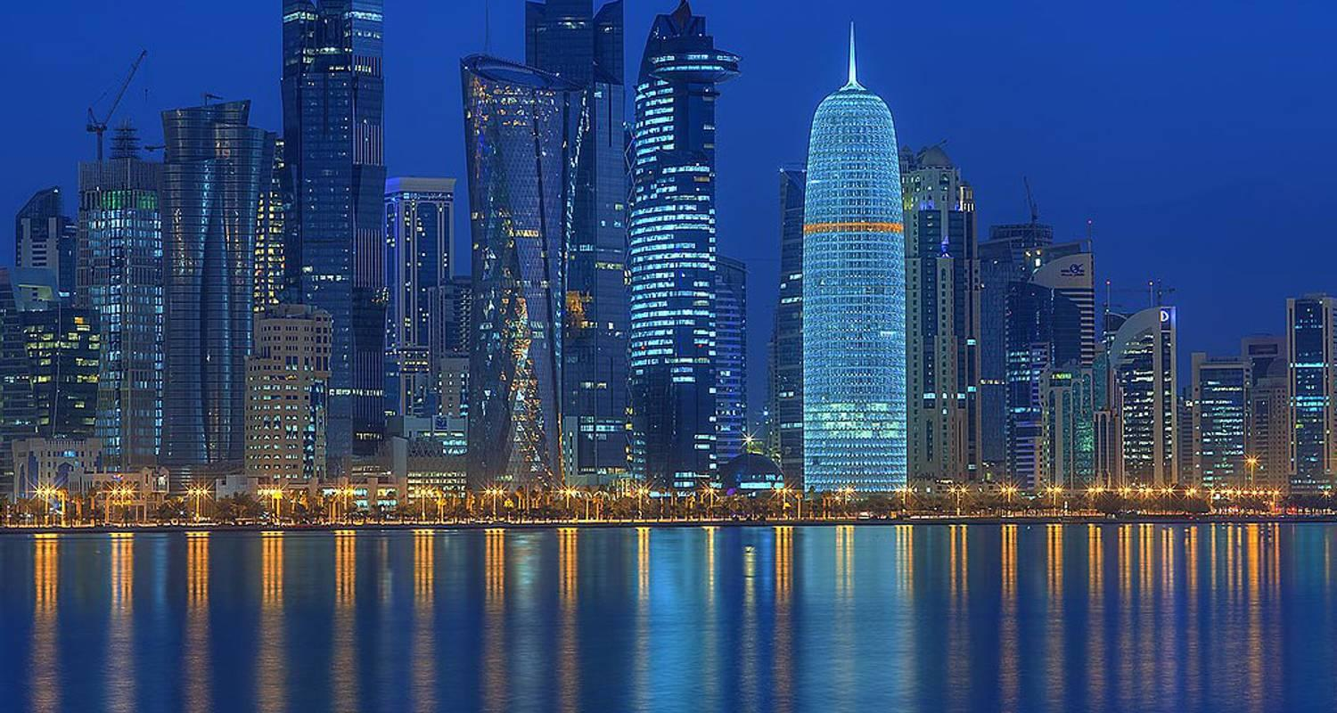

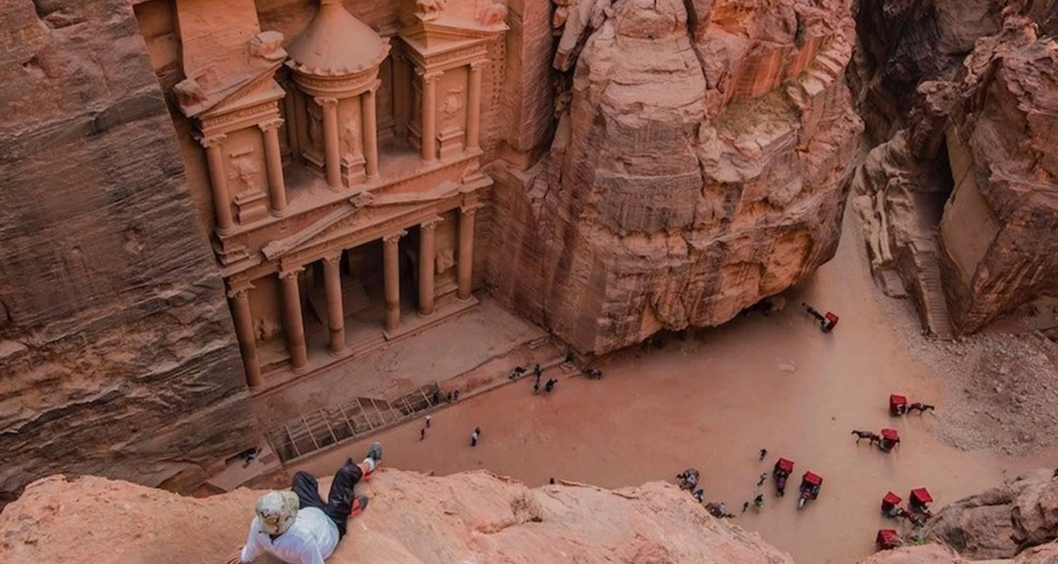

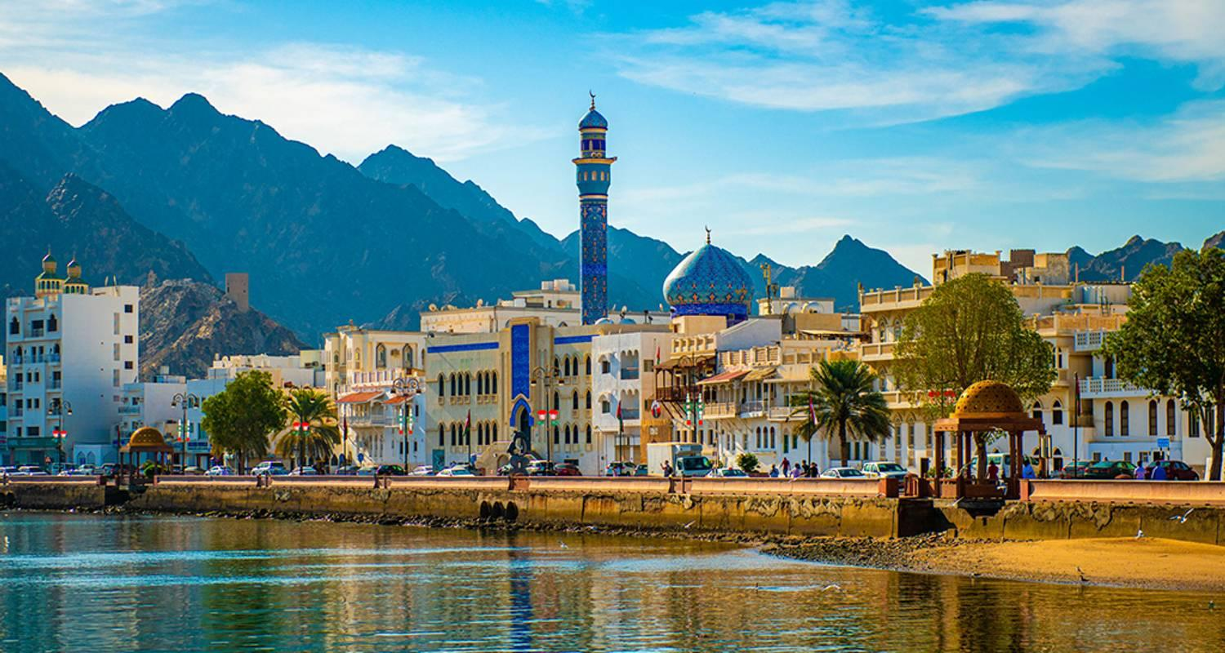





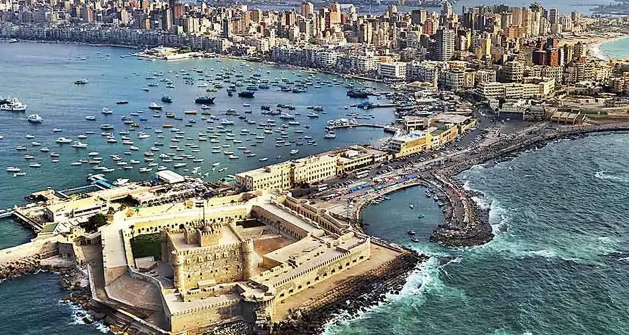

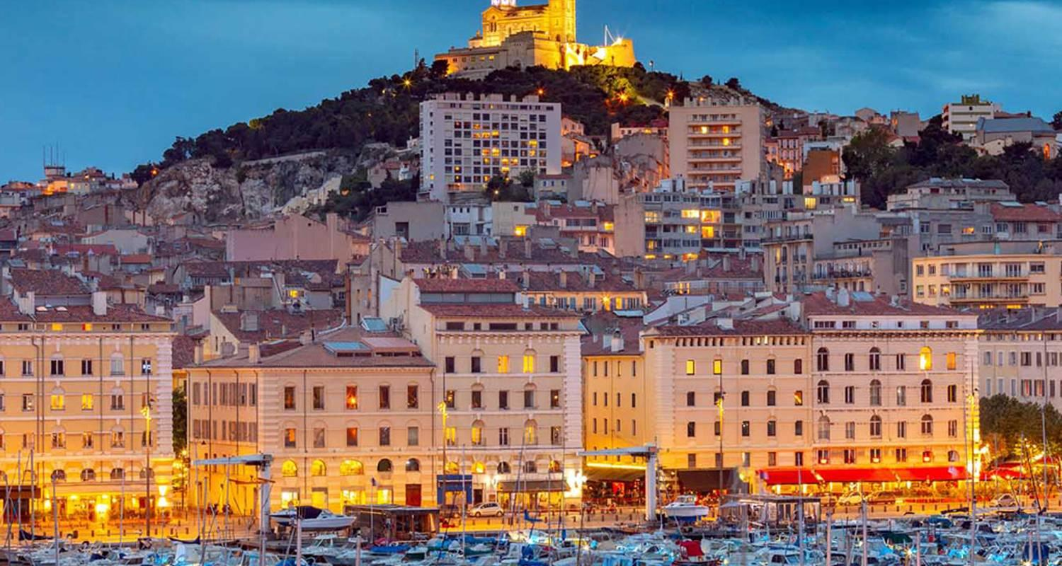

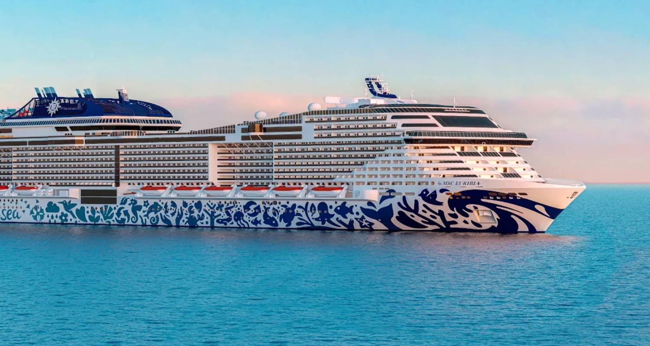

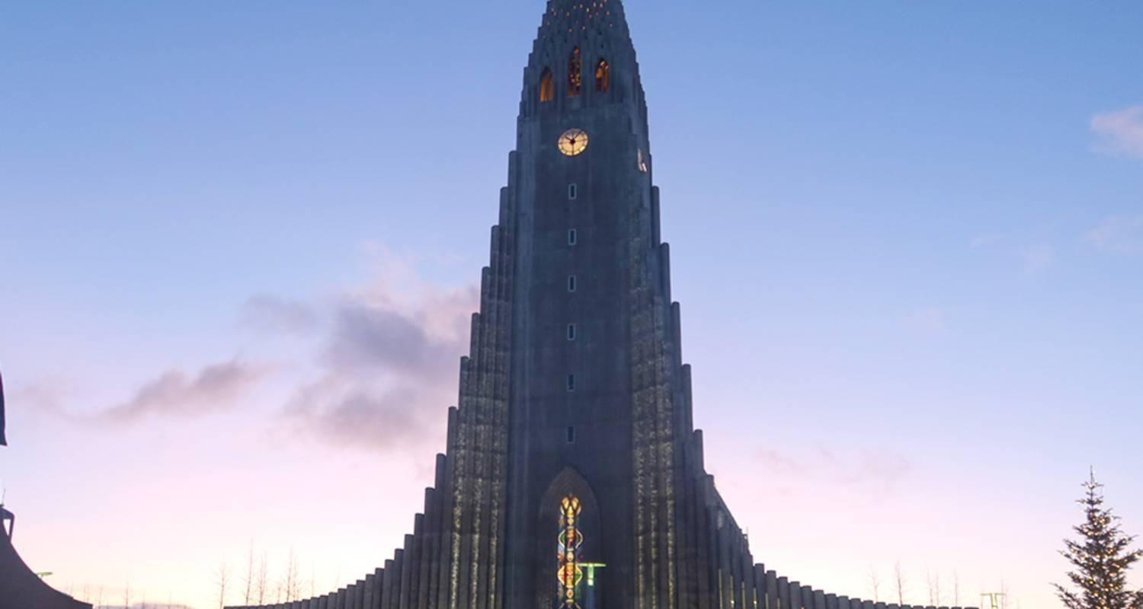

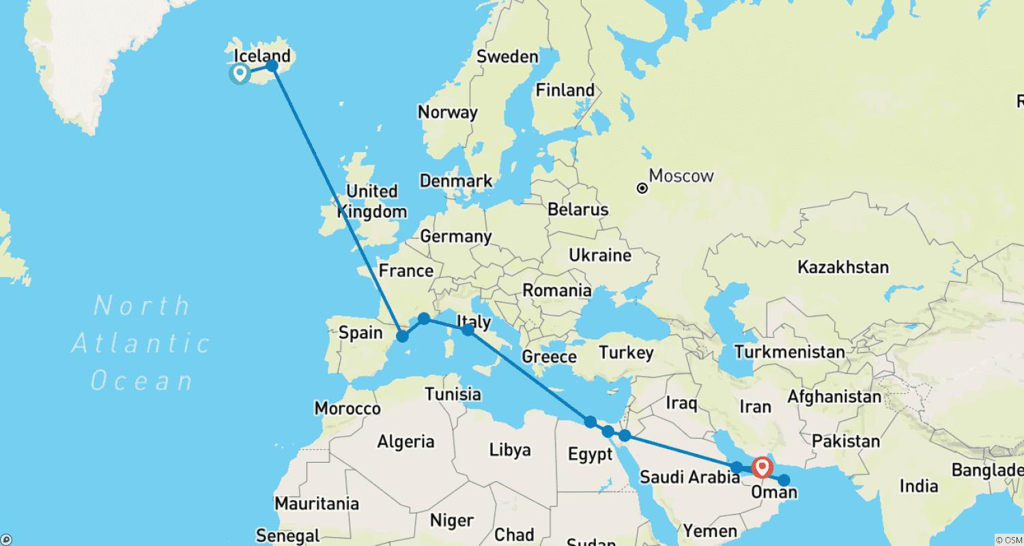

Tour ID: 263732  
Tour Name: Wild Islands of the North Atlantic | Reykjavík to Hamburg (2025)

Tour destinations: ['Reykjavik', 'Heimaey Island', 'Snæfellsnes', 'Stykkisholmur', 'Patreksfjordur', 'Akureyri', 'Godafoss', 'Grimsey', 'Seydisfjordur', 'Runavík', 'Streymoy Island', 'Lerwick', 'Fair Isle', 'Edinburgh', 'Hamburg']

Tour destinations images:

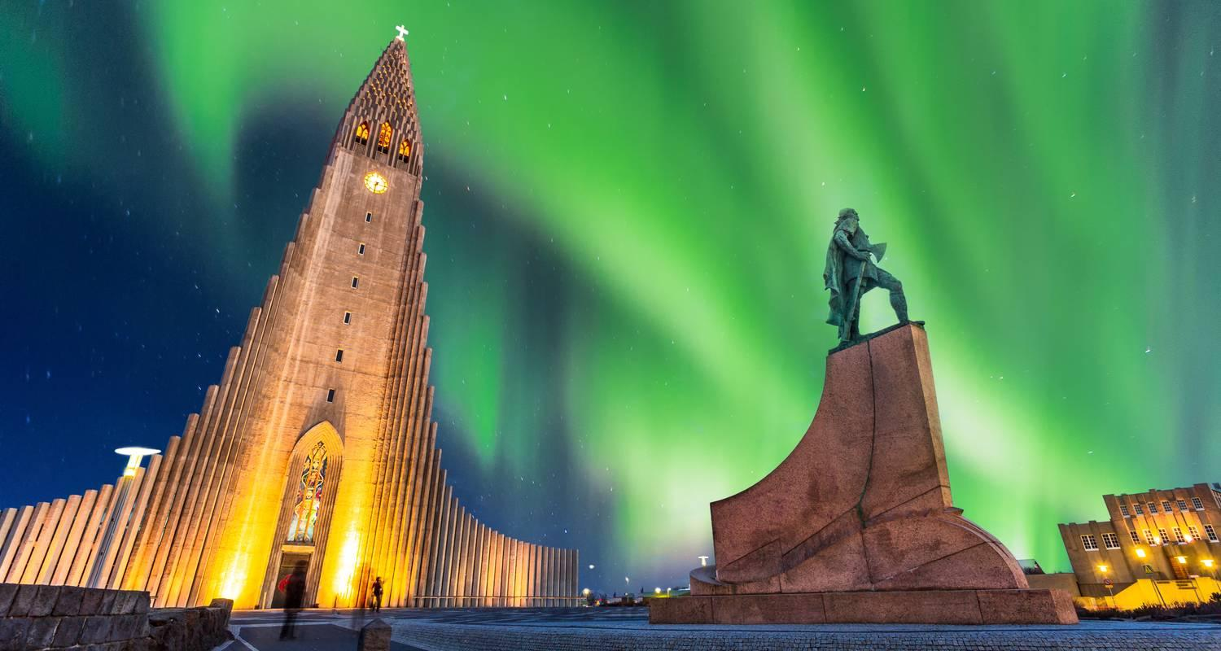

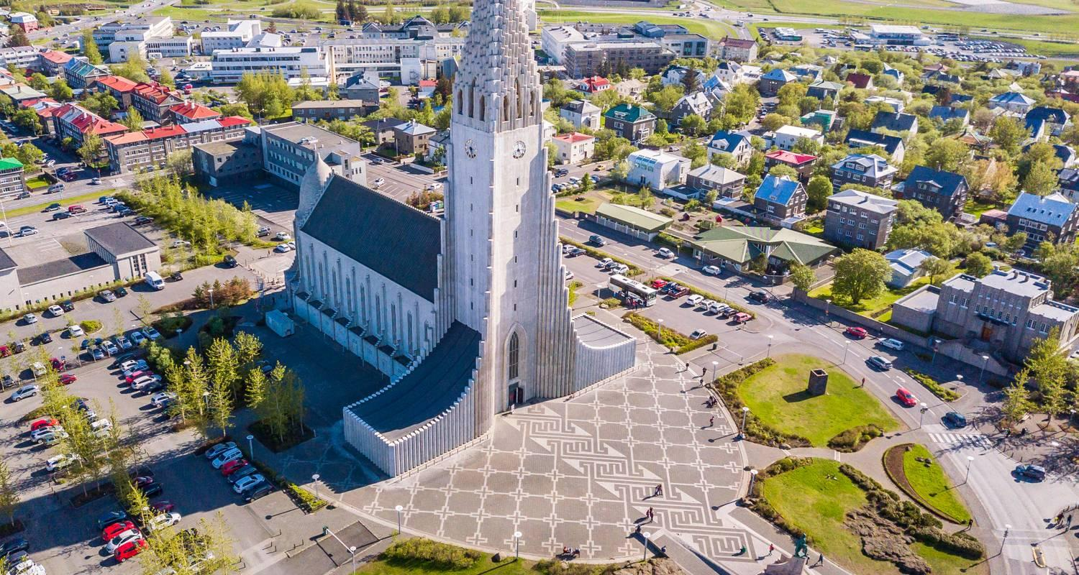

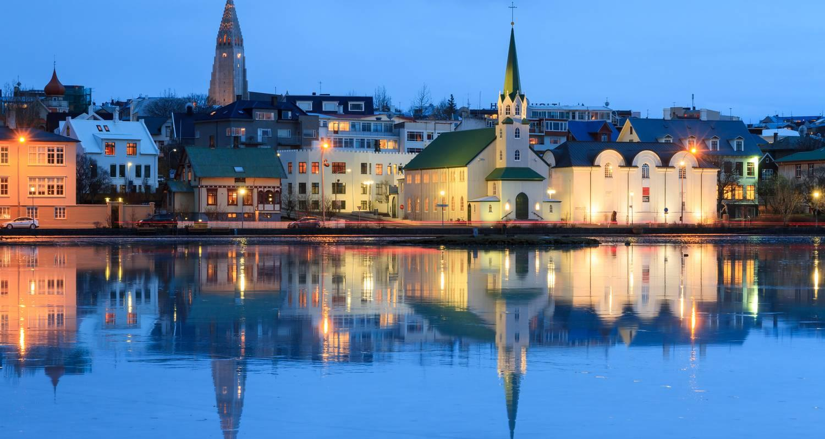

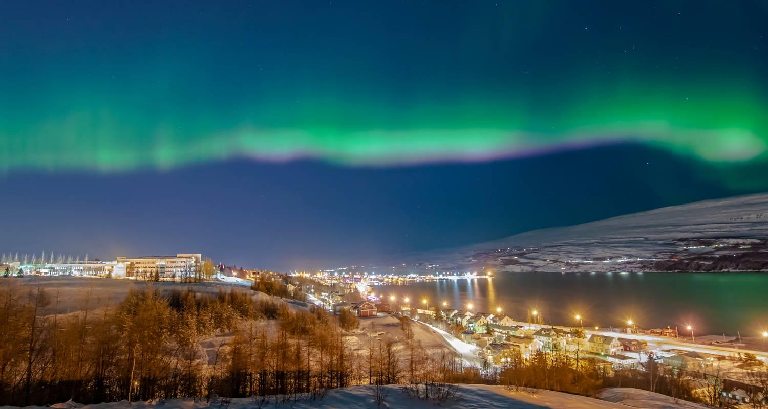

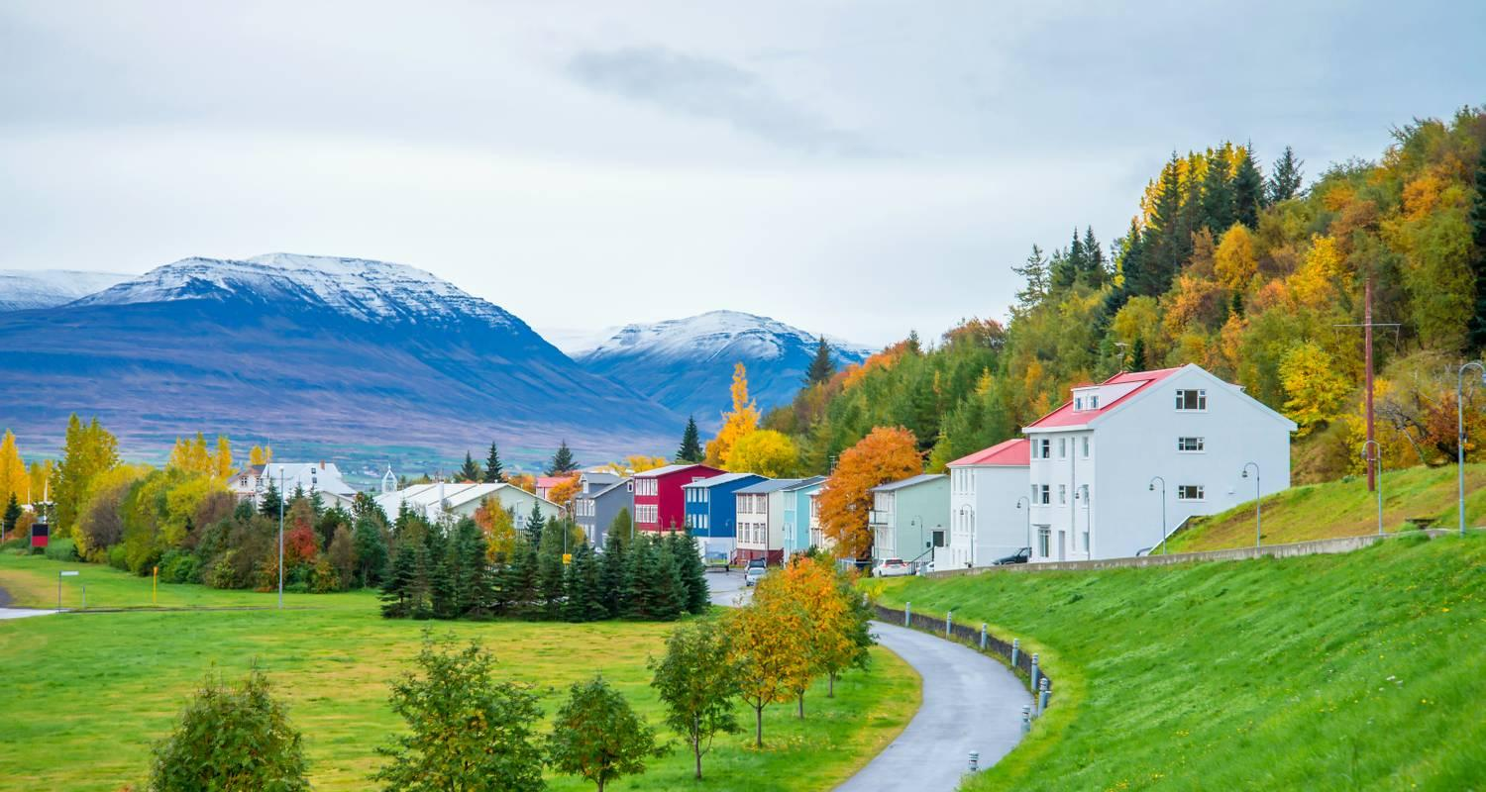

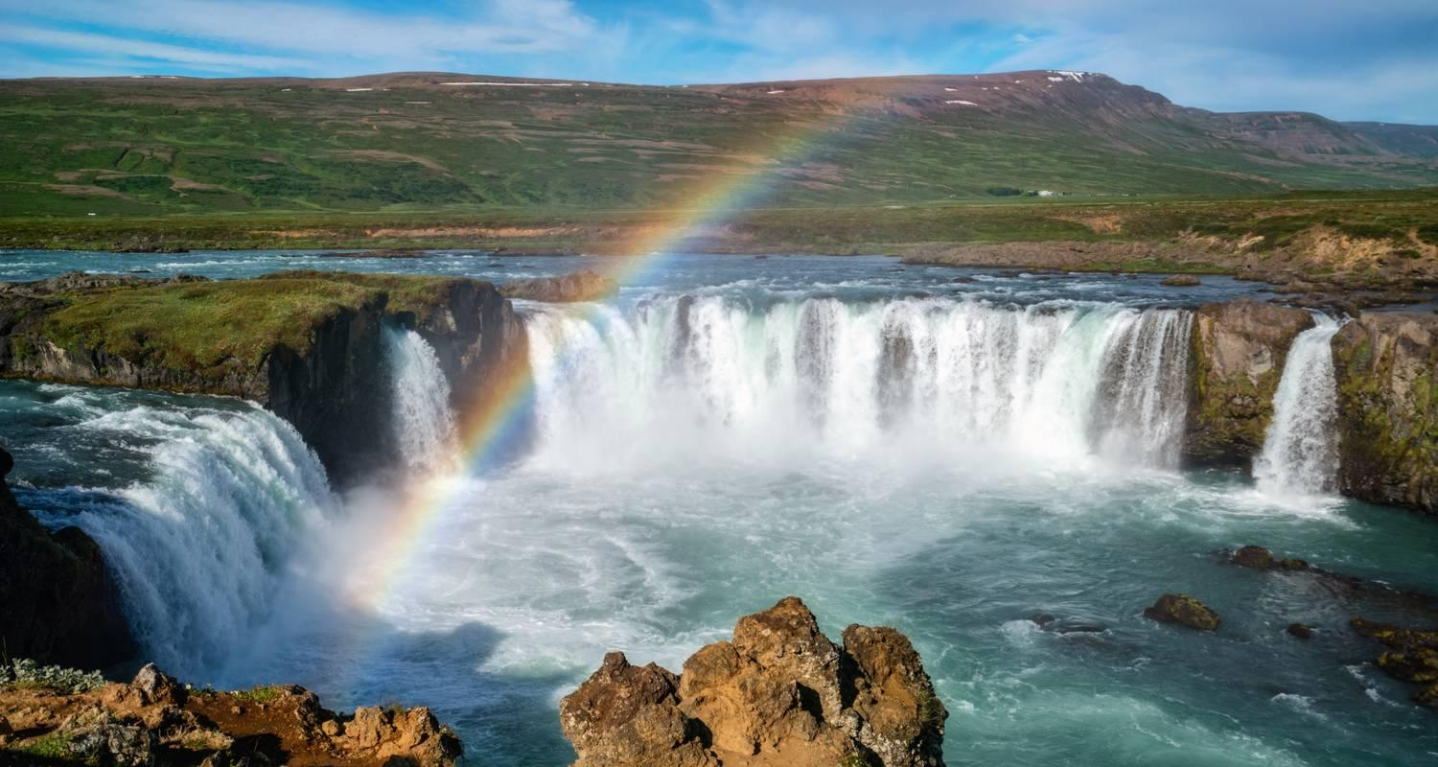

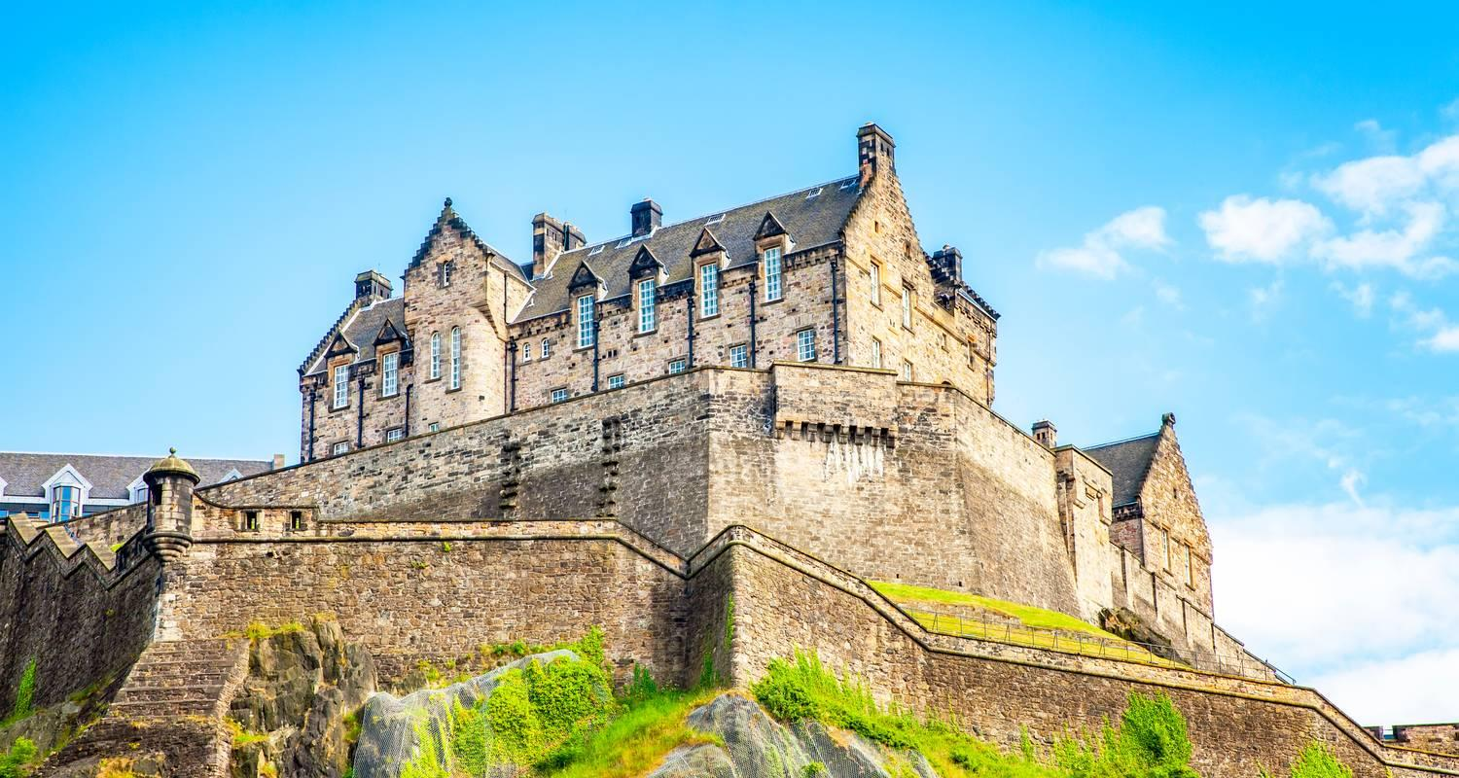

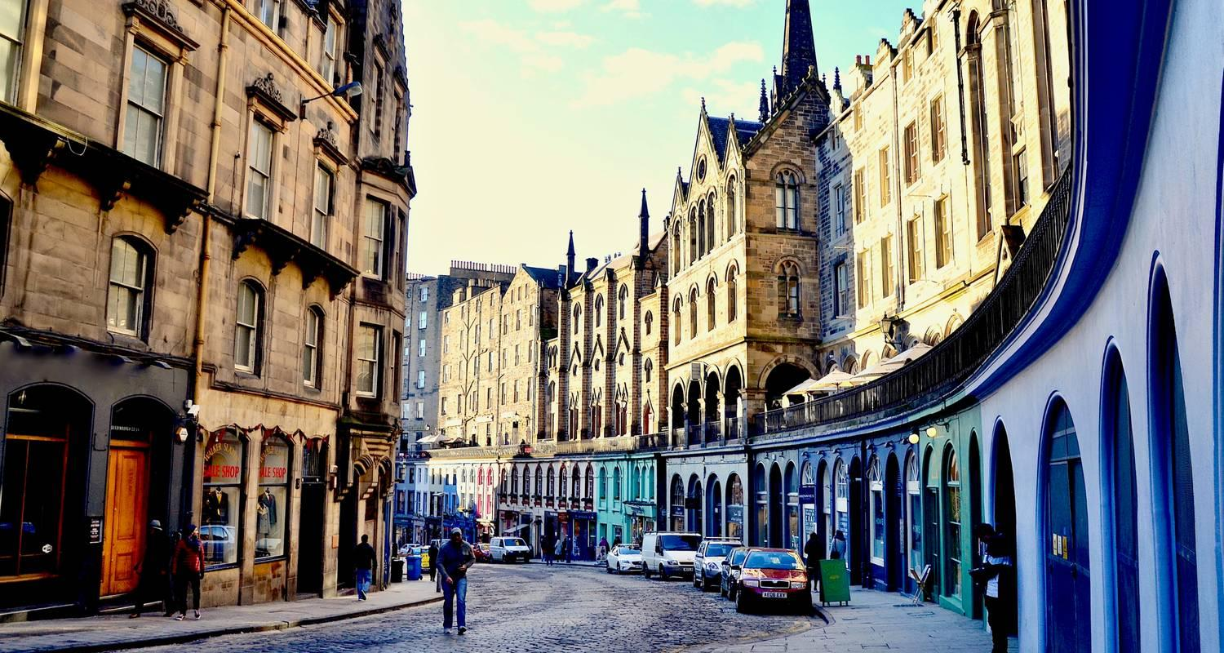

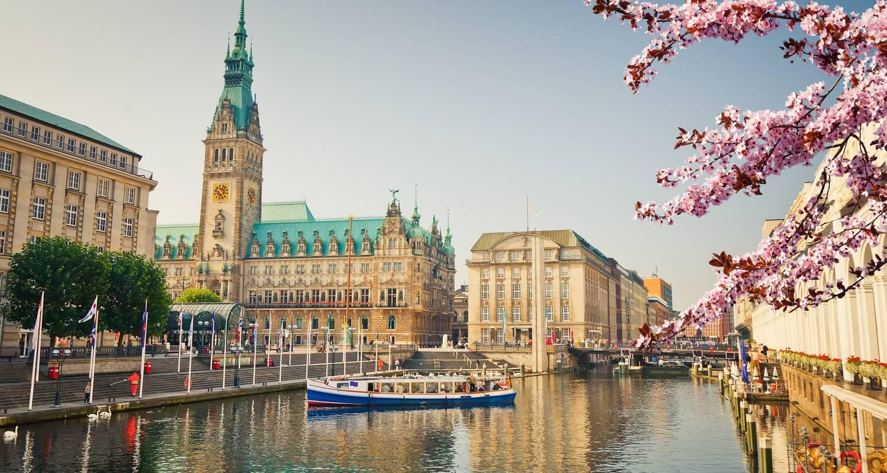

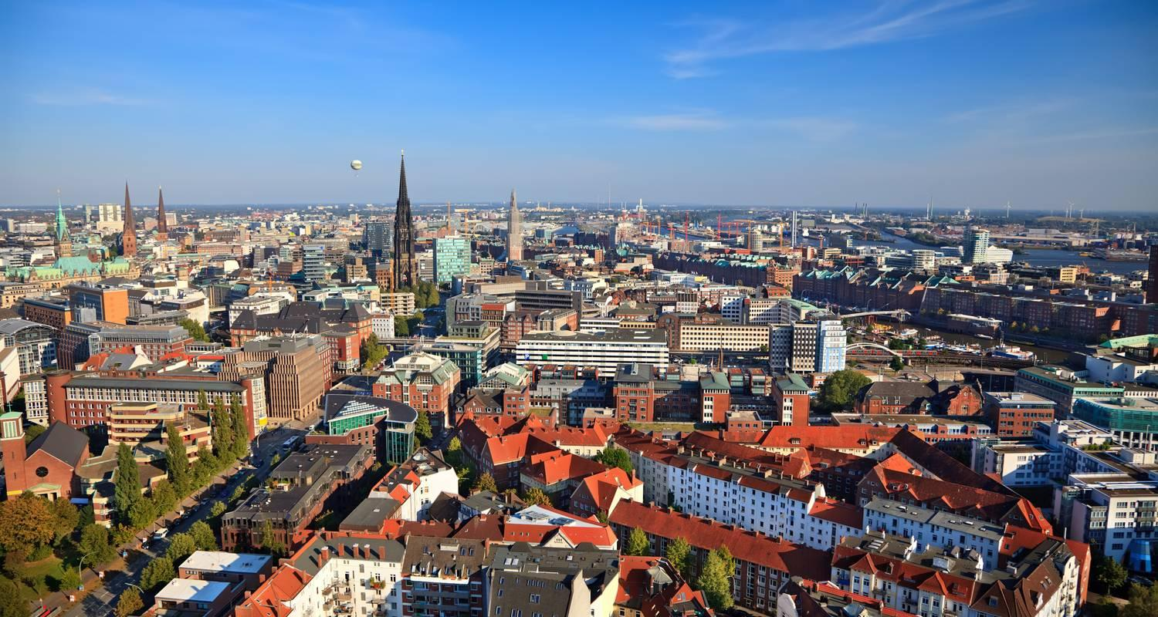

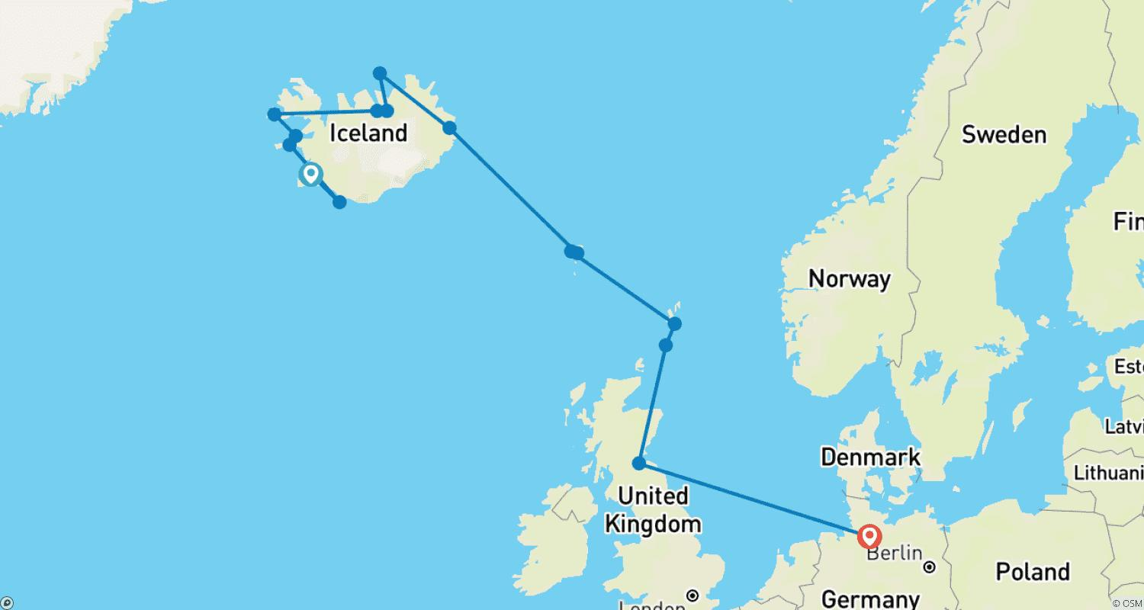

Tour ID: 263738  
Tour Name: A True Arctic Expedition | East Greenland & Svalbard (2025)

Tour destinations: ['Reykjavik', 'Isafjordur', 'Jan Mayen Island', 'Svalbard', 'Scoresby Sound', 'Ittoqqortoormiit']

Tour destinations images:





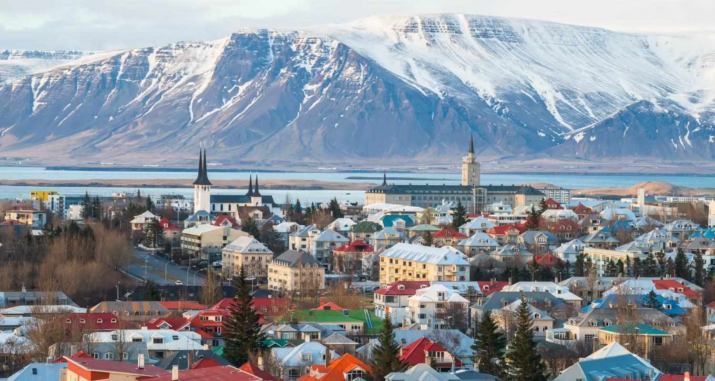

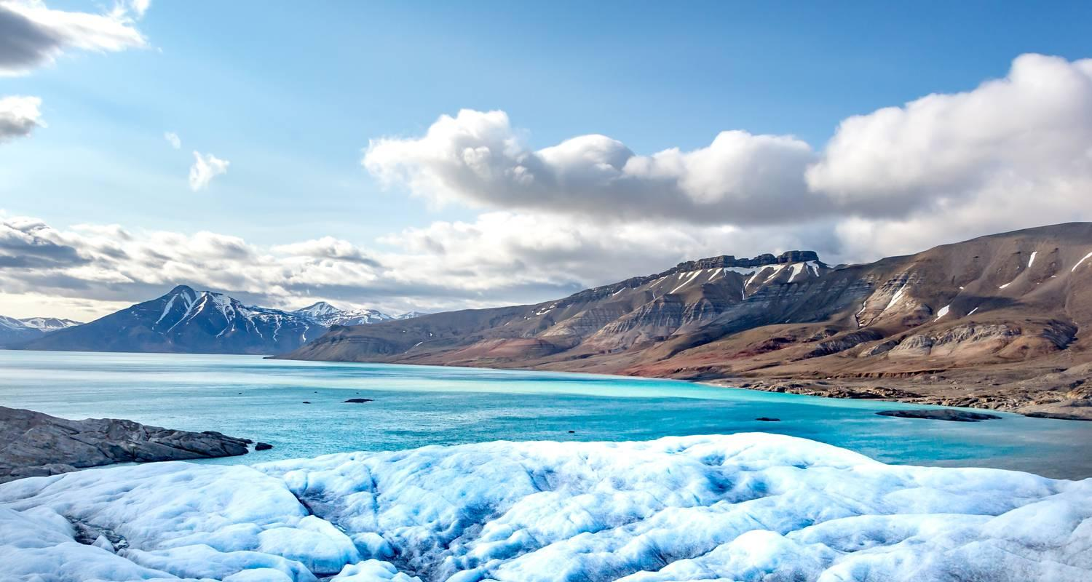

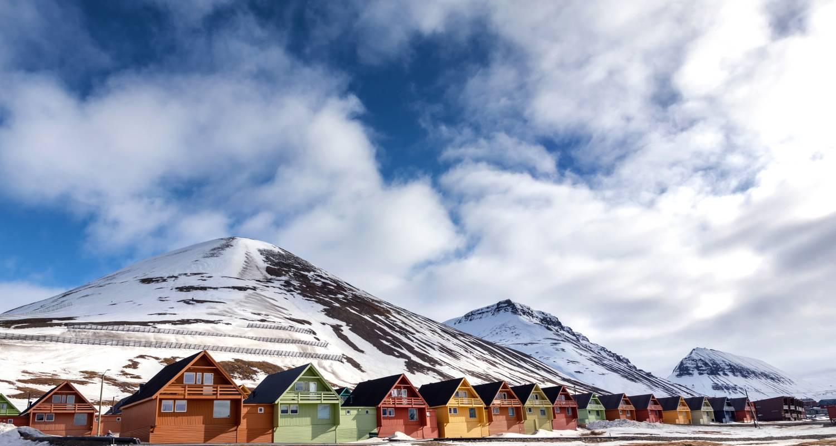

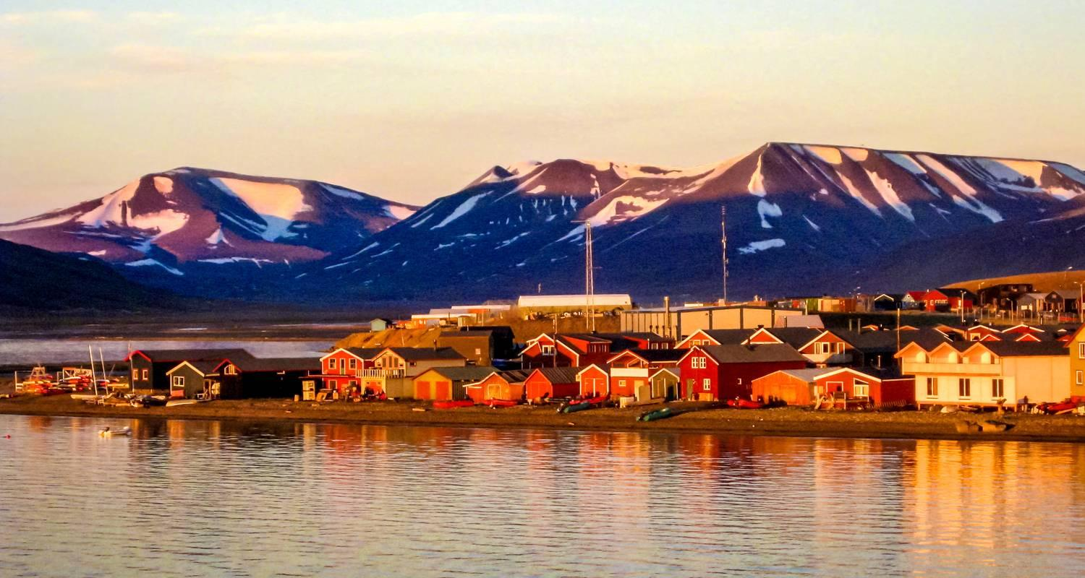

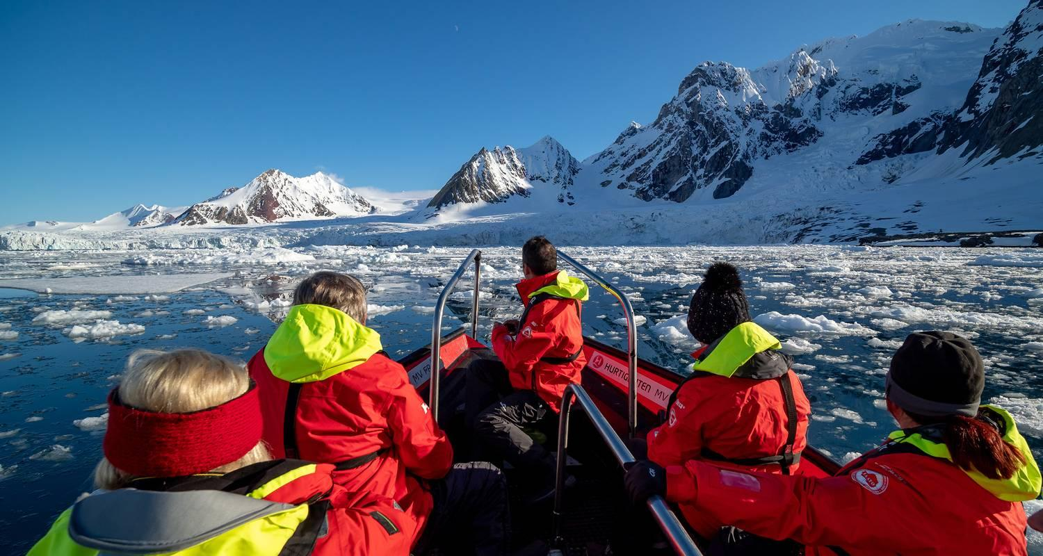

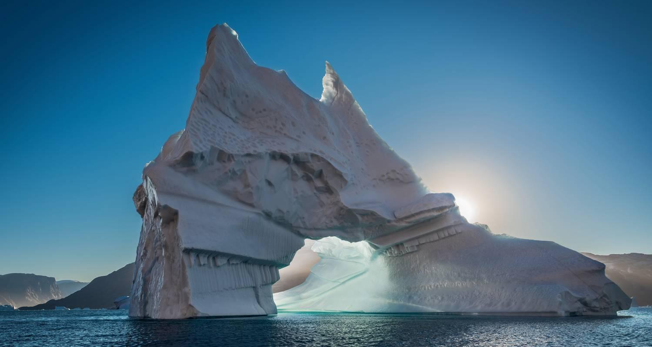

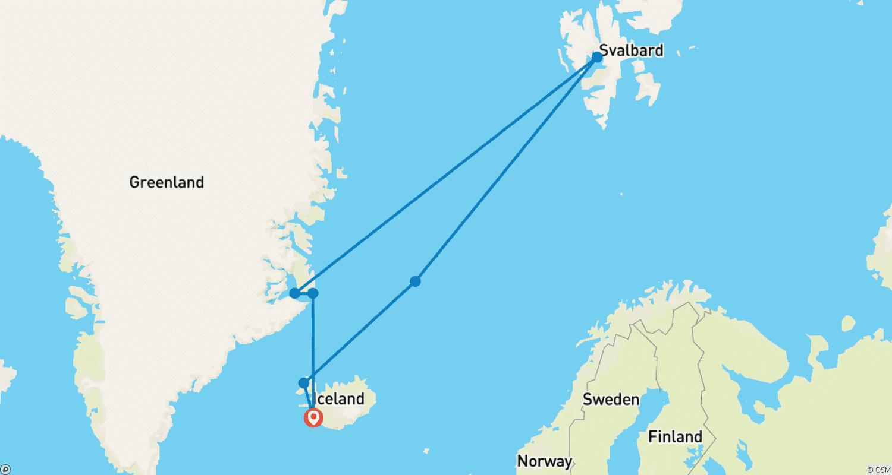

Tour ID: 263740  
Tour Name: Elemental Iceland – Circular Saga from Reykjavík (MS Maud)

Tour destinations: ['Reykjavik', 'Snæfellsnes', 'Isafjordur', 'Akureyri', 'Godafoss', 'Husavik', 'Bakkagerdi', 'Heimaey Island']

Tour destinations images:





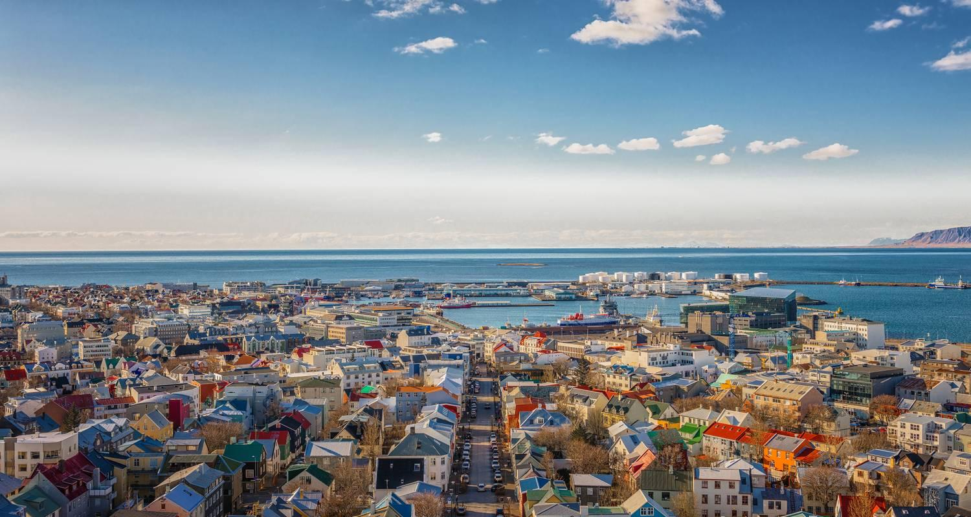







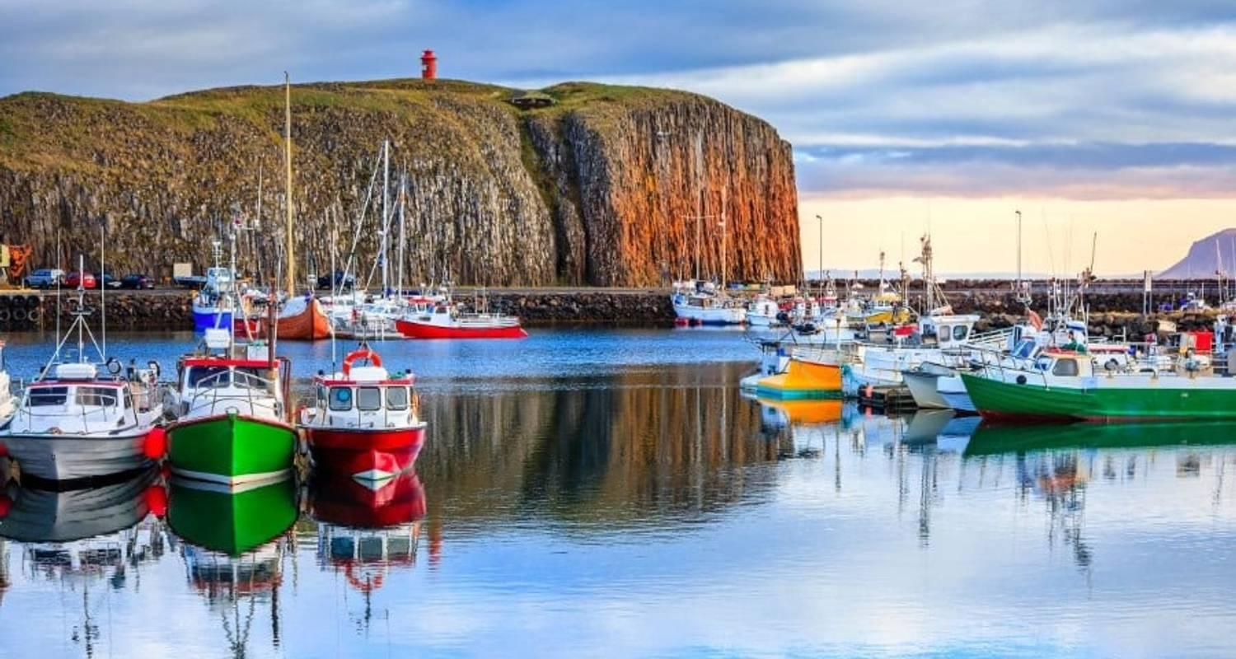

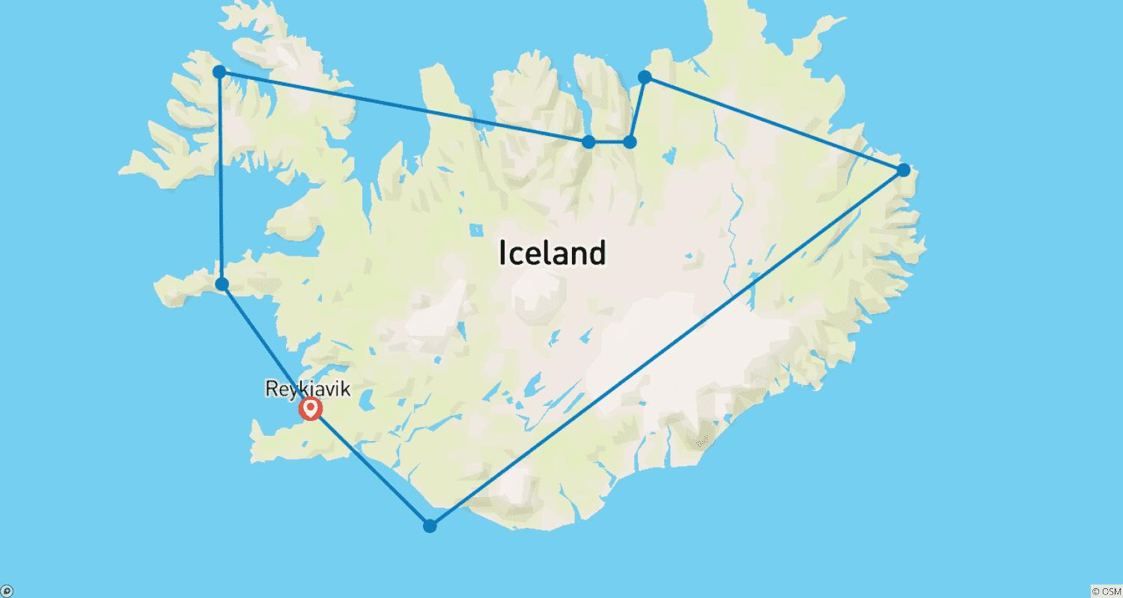

Tour ID: 263748  
Tour Name: Arctic Island Odyssey - Svalbard, Greenland and Iceland

Tour destinations: ['Oslo', 'Longyearbyen', 'Northeast Greenland National Park', 'Scoresby Sound', 'Reykjavik']

Tour destinations images:

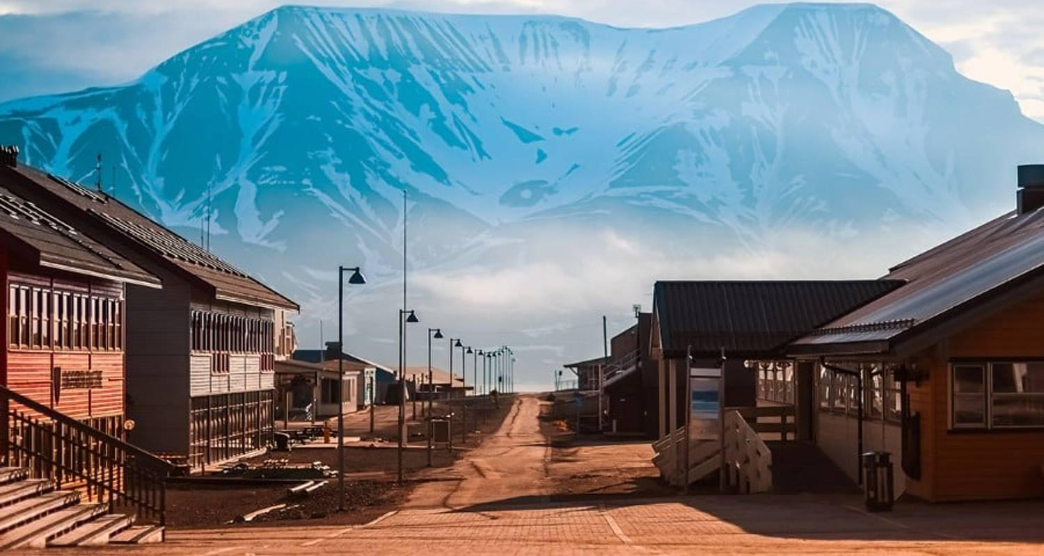

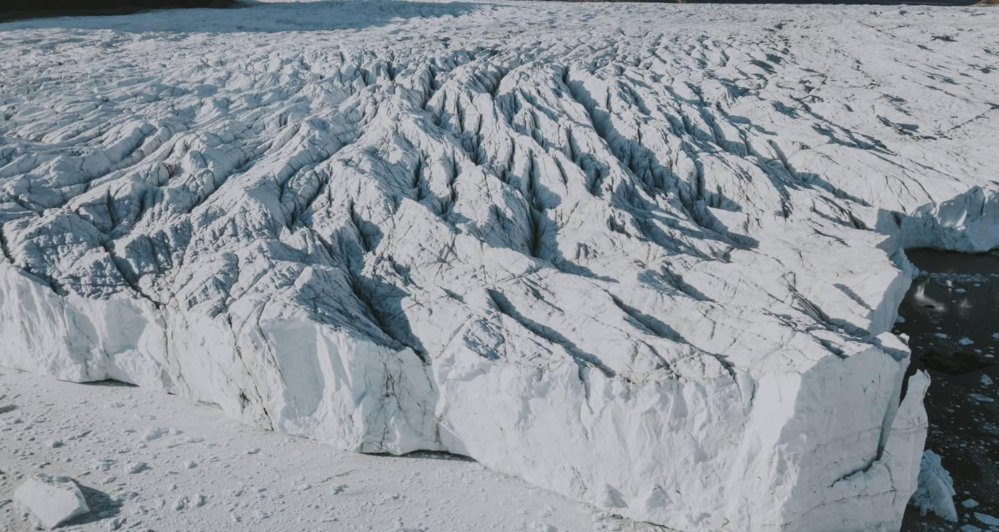

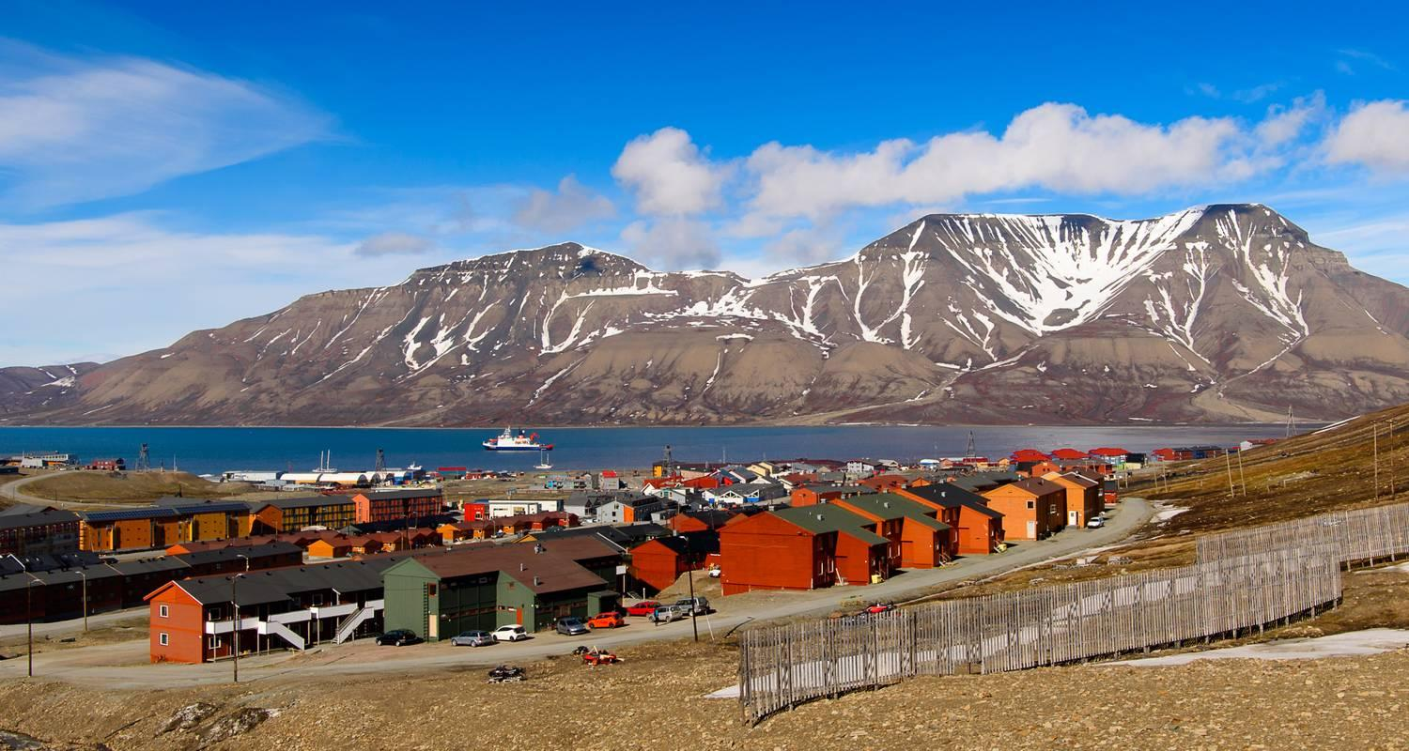

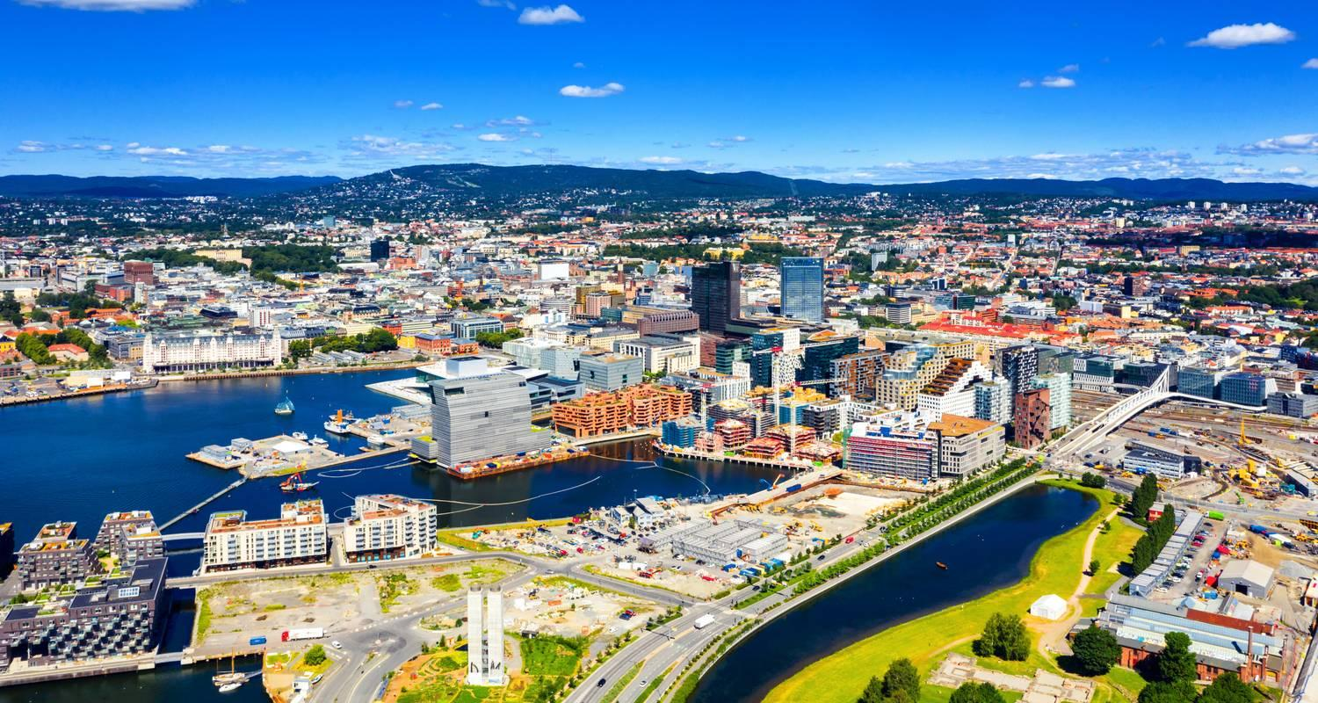

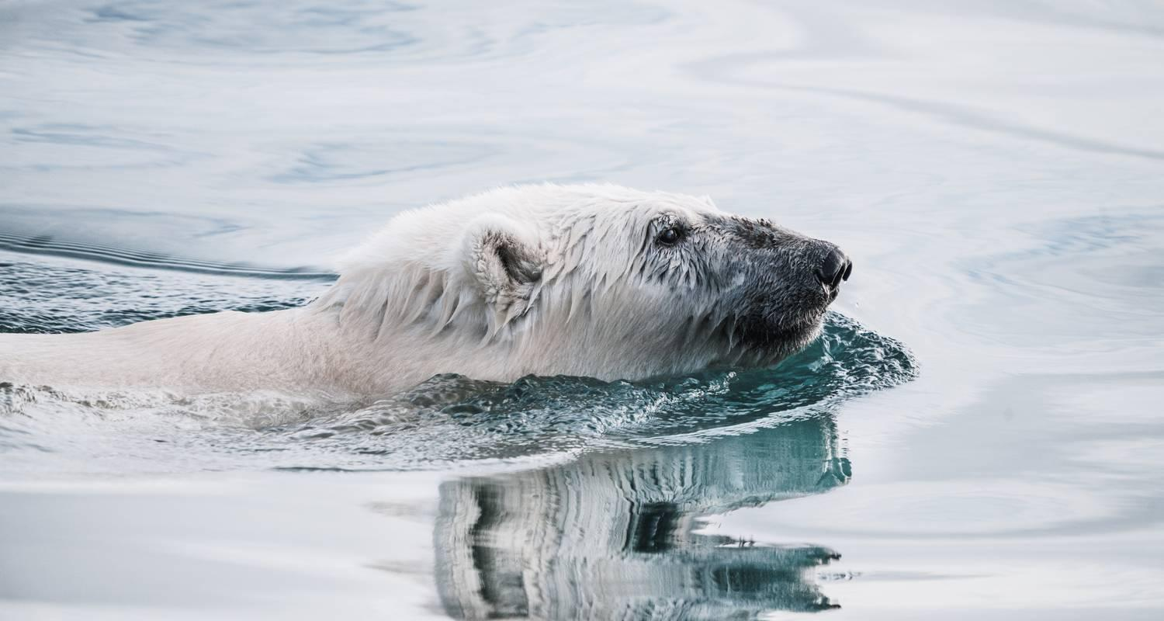

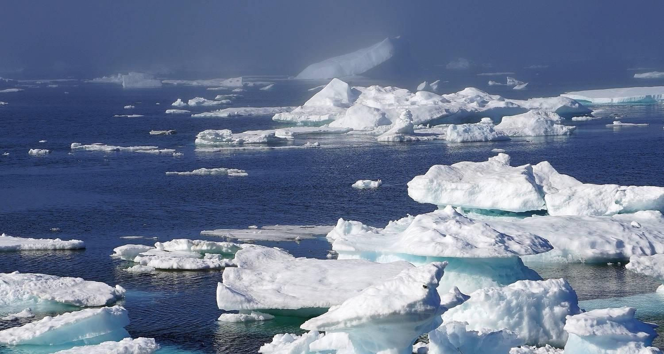

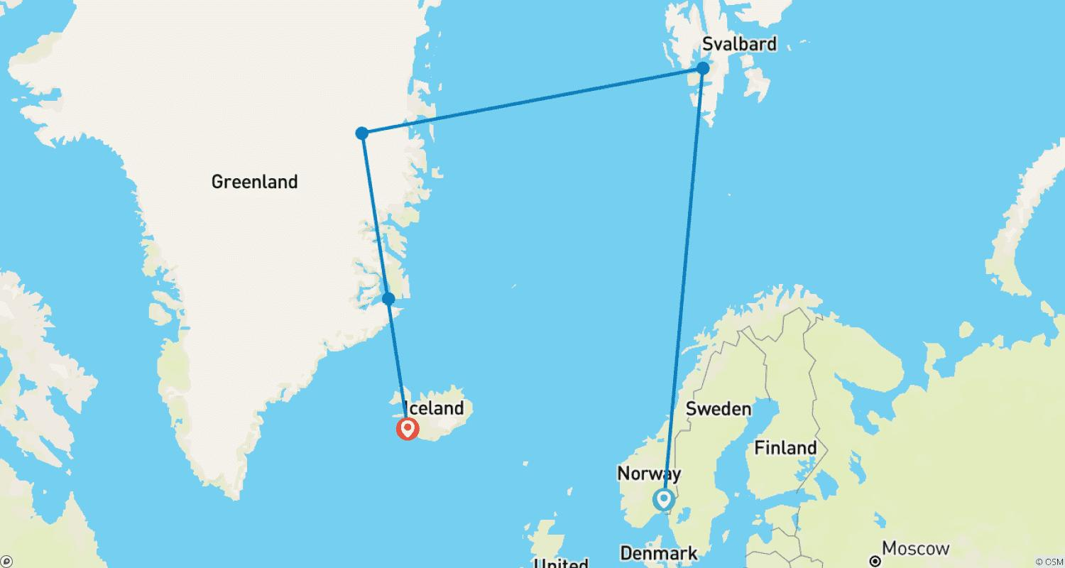

Tour ID: 264193  
Tour Name: Expedition to Iceland - Hamburg to Reykjavík via Scotland's Northern Isles (MS Maud, 2025)

Tour destinations: ['Hamburg', 'Lysefjorden', 'Lerwick', 'Faroe Islands', 'Seydisfjordur', 'Grimsey', 'Akureyri', 'Patreksfjordur', 'Snæfellsnes', 'Heimaey Island', 'Reykjavik']

Tour destinations images:

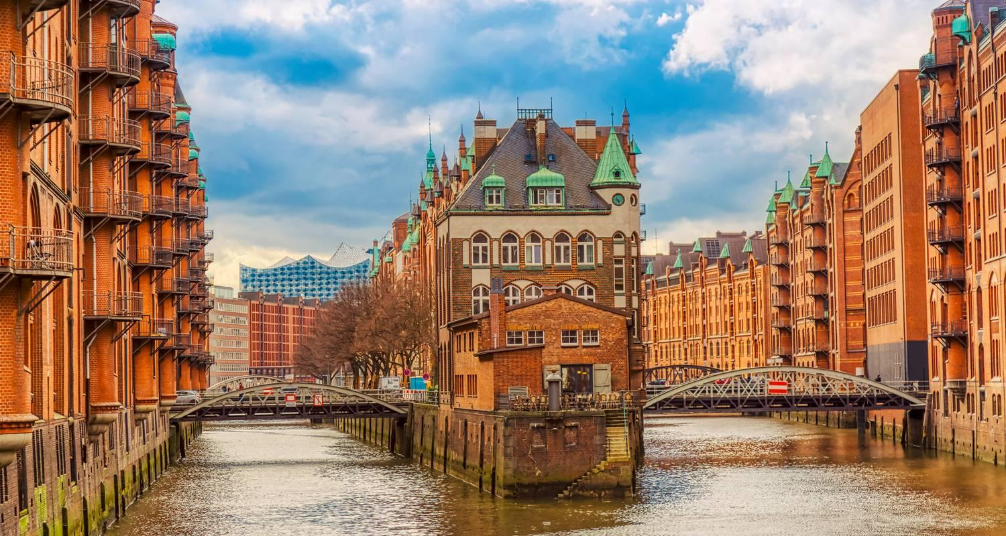









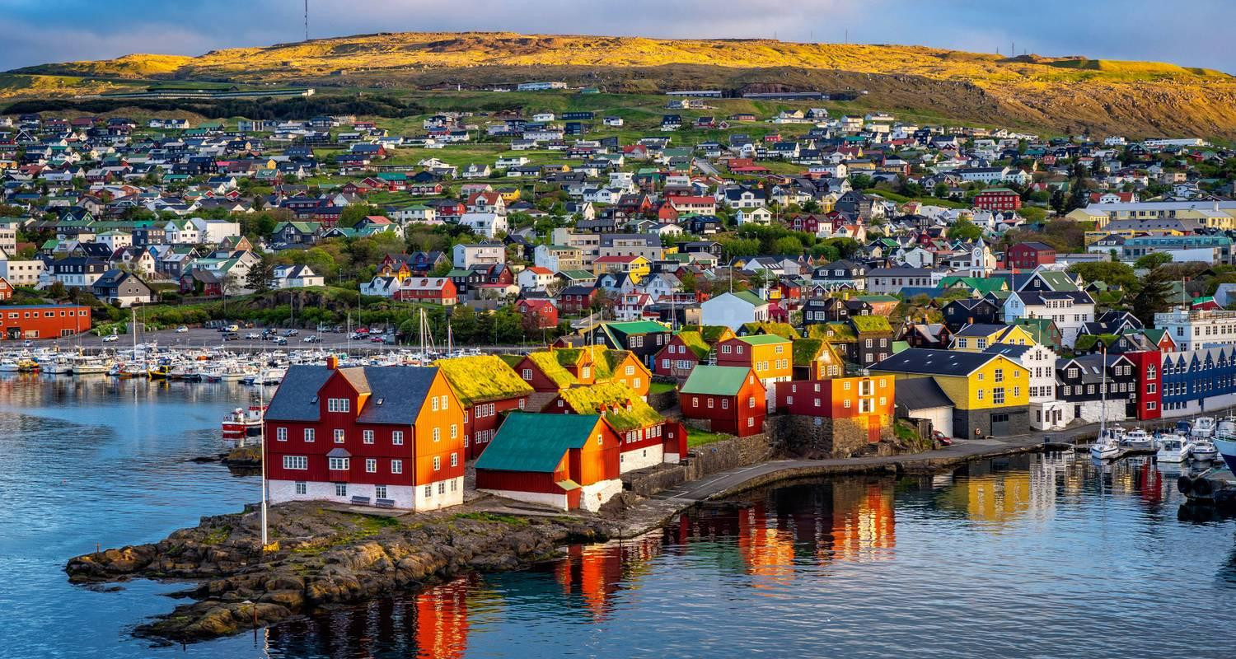

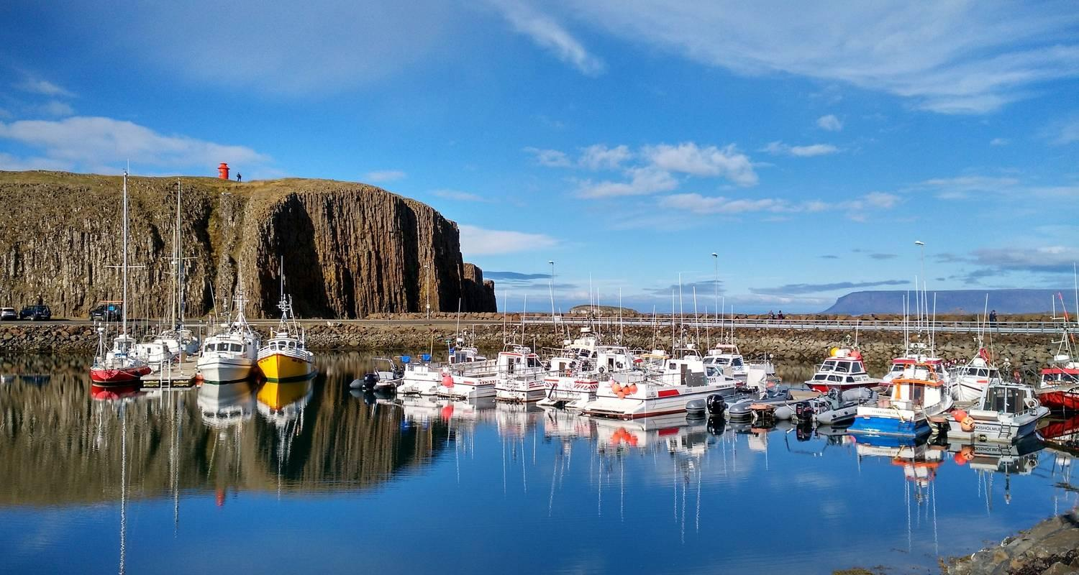

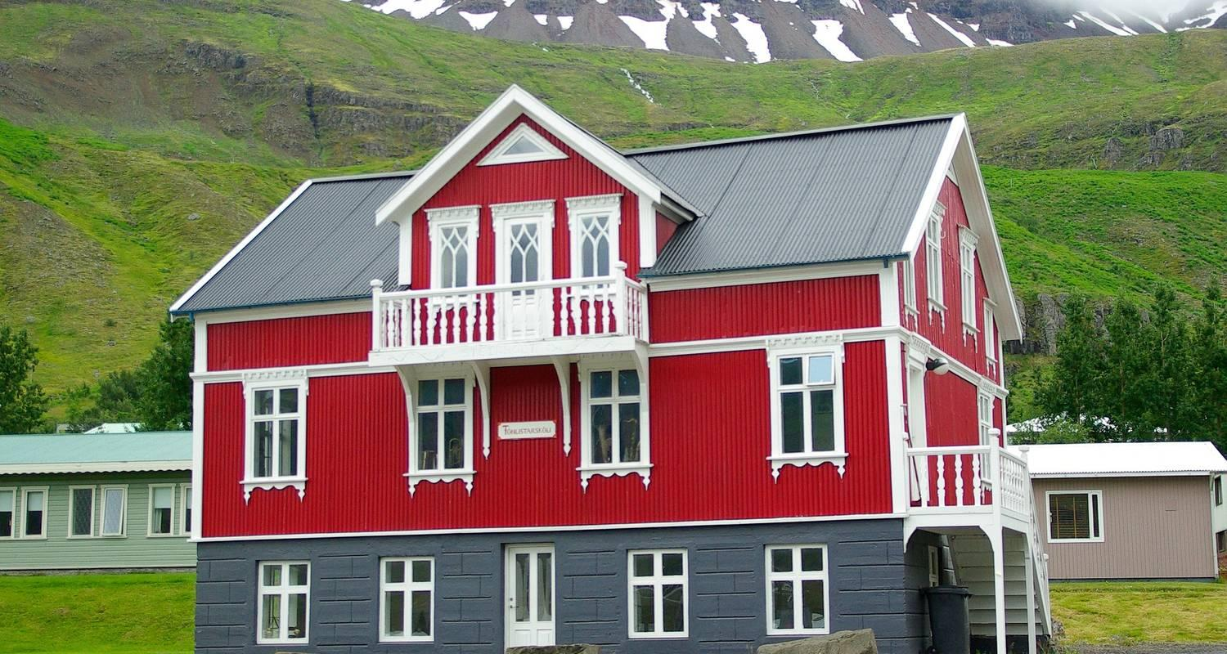

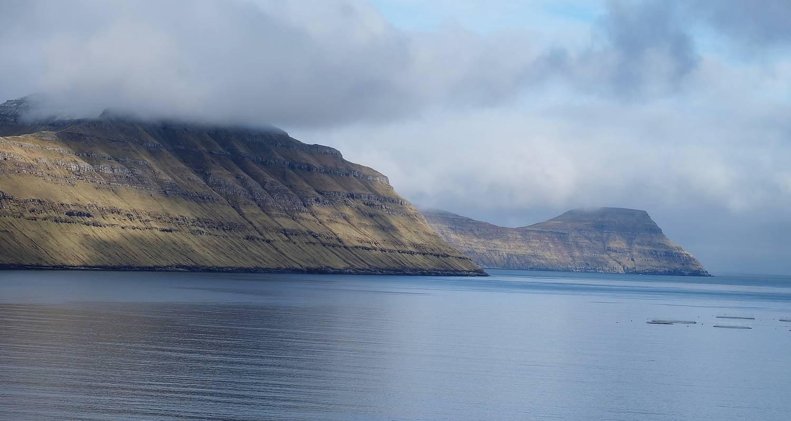

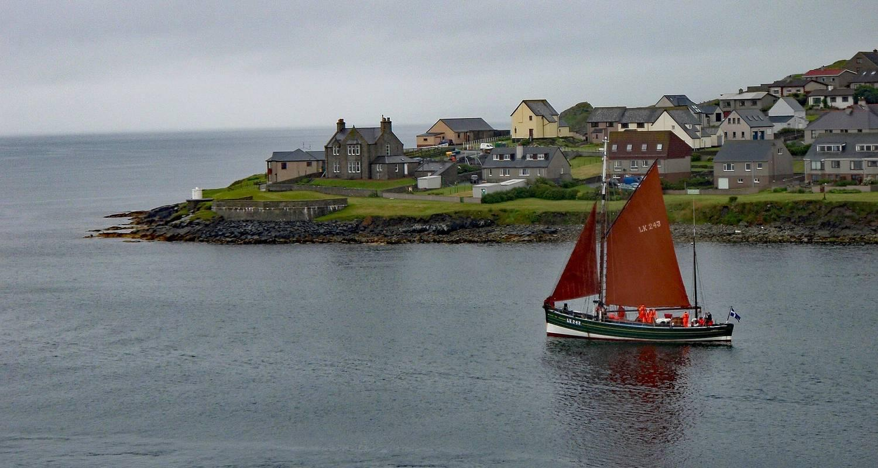

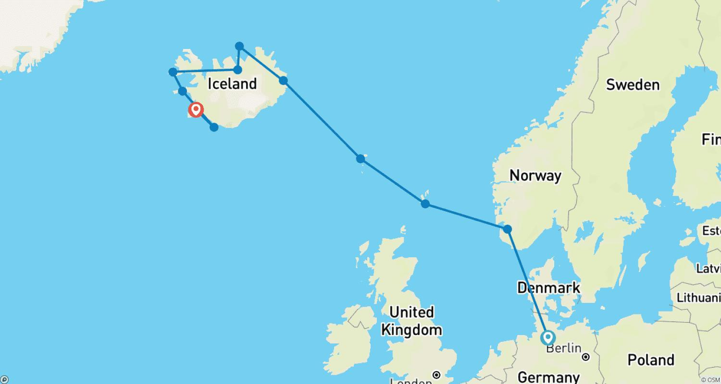

Tour ID: 265936  
Tour Name: Grand Greenland – The Icy Giants of Disko Bay

Tour destinations: ['Reykjavik', 'Nuuk', 'Disko Bay', 'Uummannaq']

Tour destinations images:

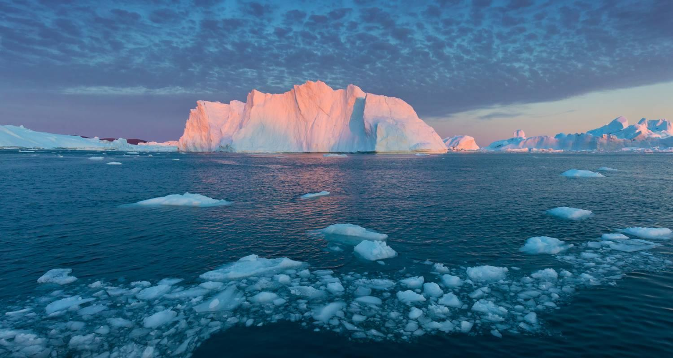

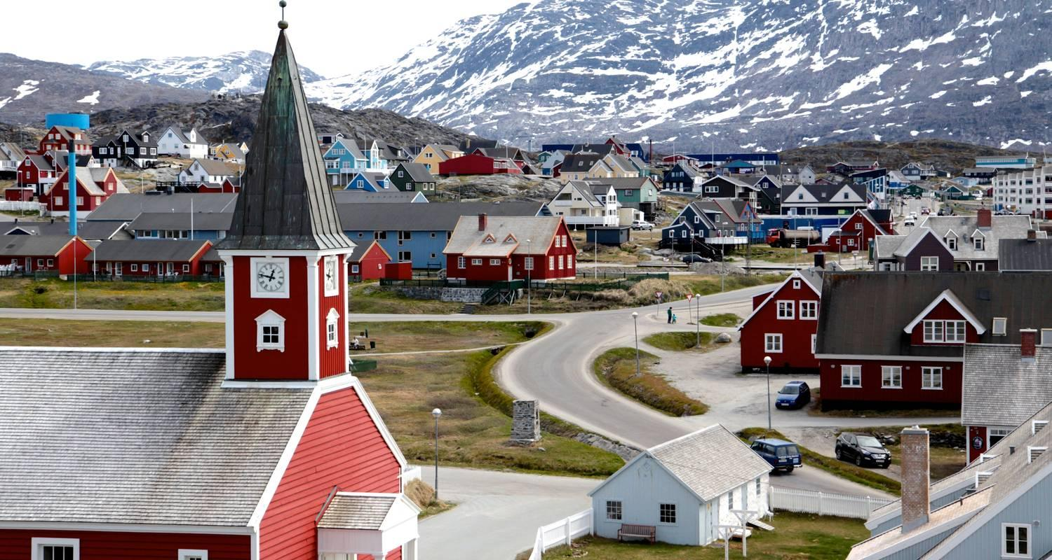



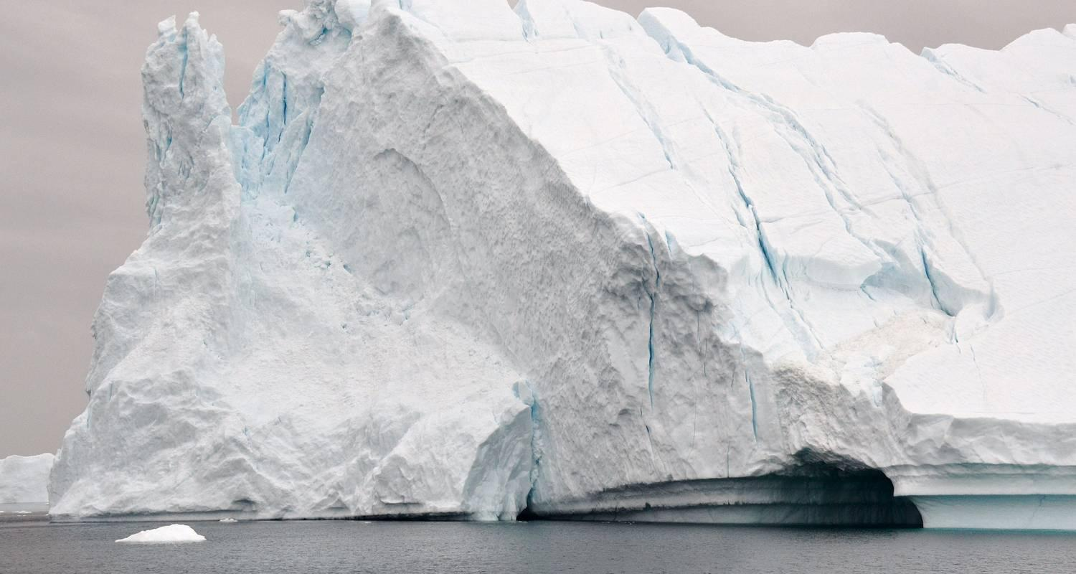



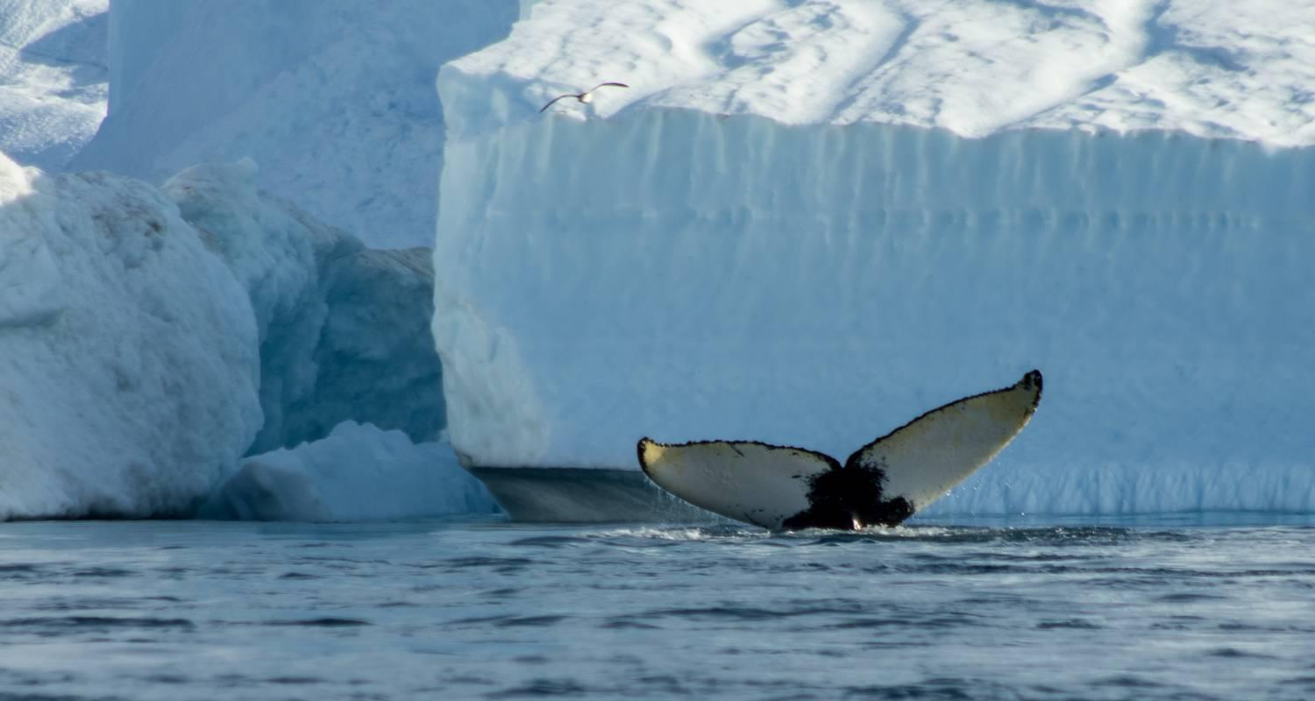

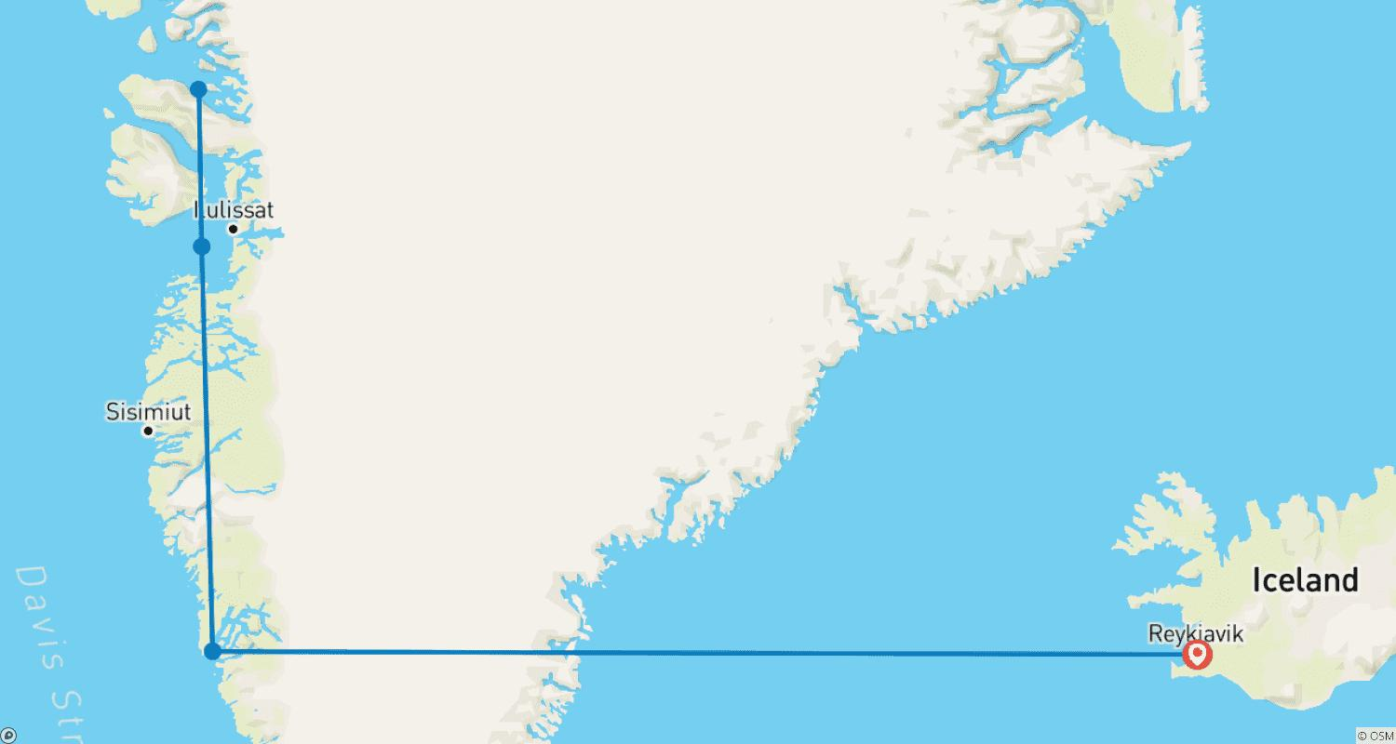

Tour ID: 265937  
Tour Name: Grand Greenland – Mythical Lands of the North

Tour destinations: ['Reykjavik', 'Nuuk', 'Disko Bay', 'Ilulissat', 'Nuussuaq', 'Thule', 'Disko Island', 'Itilleq']

Tour destinations images:







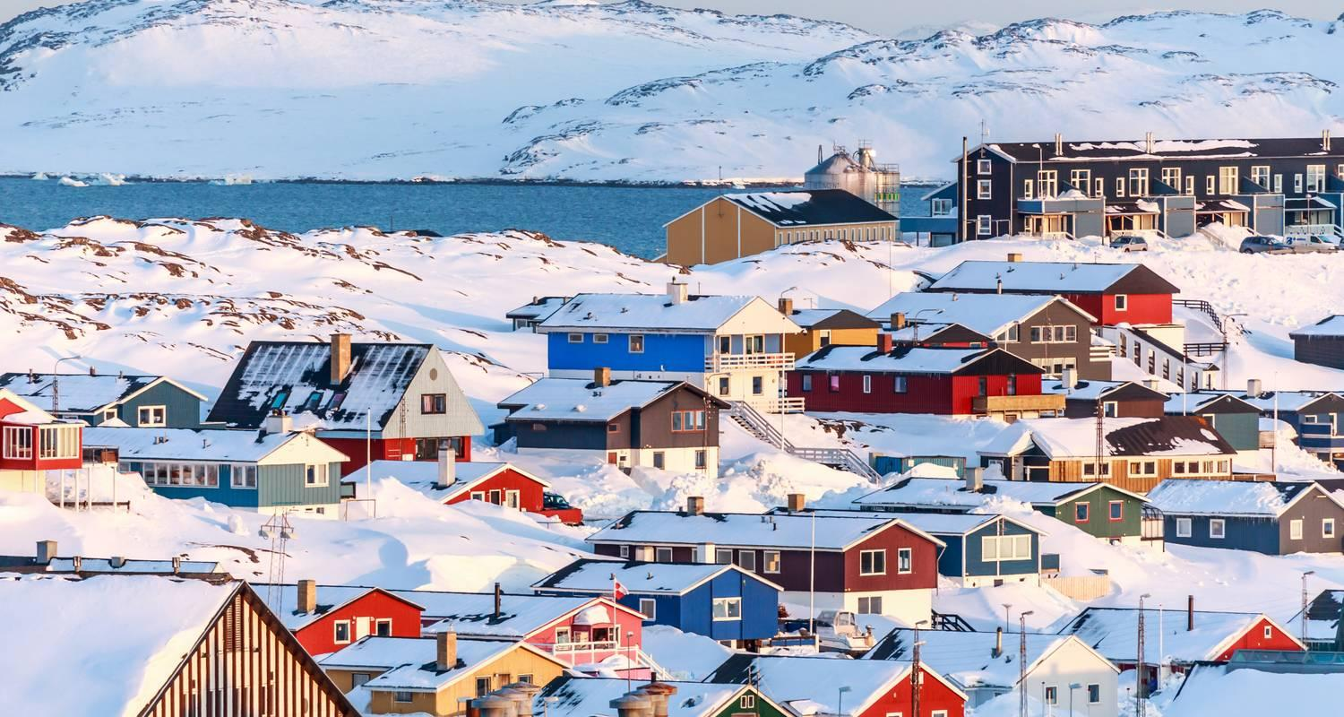

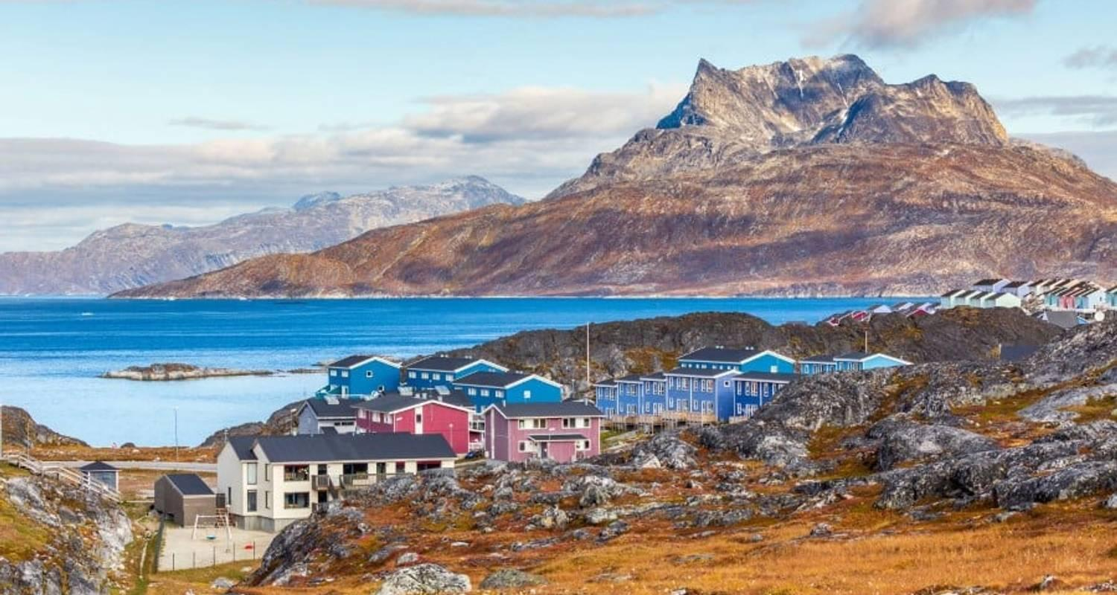

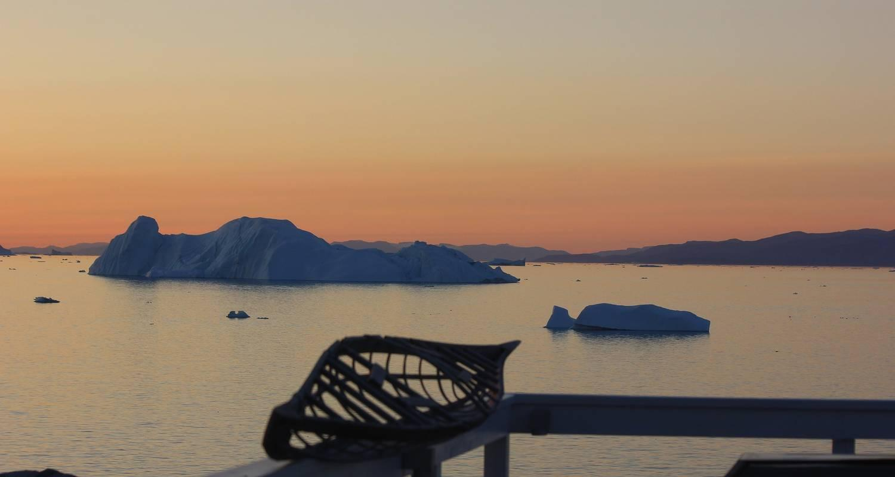

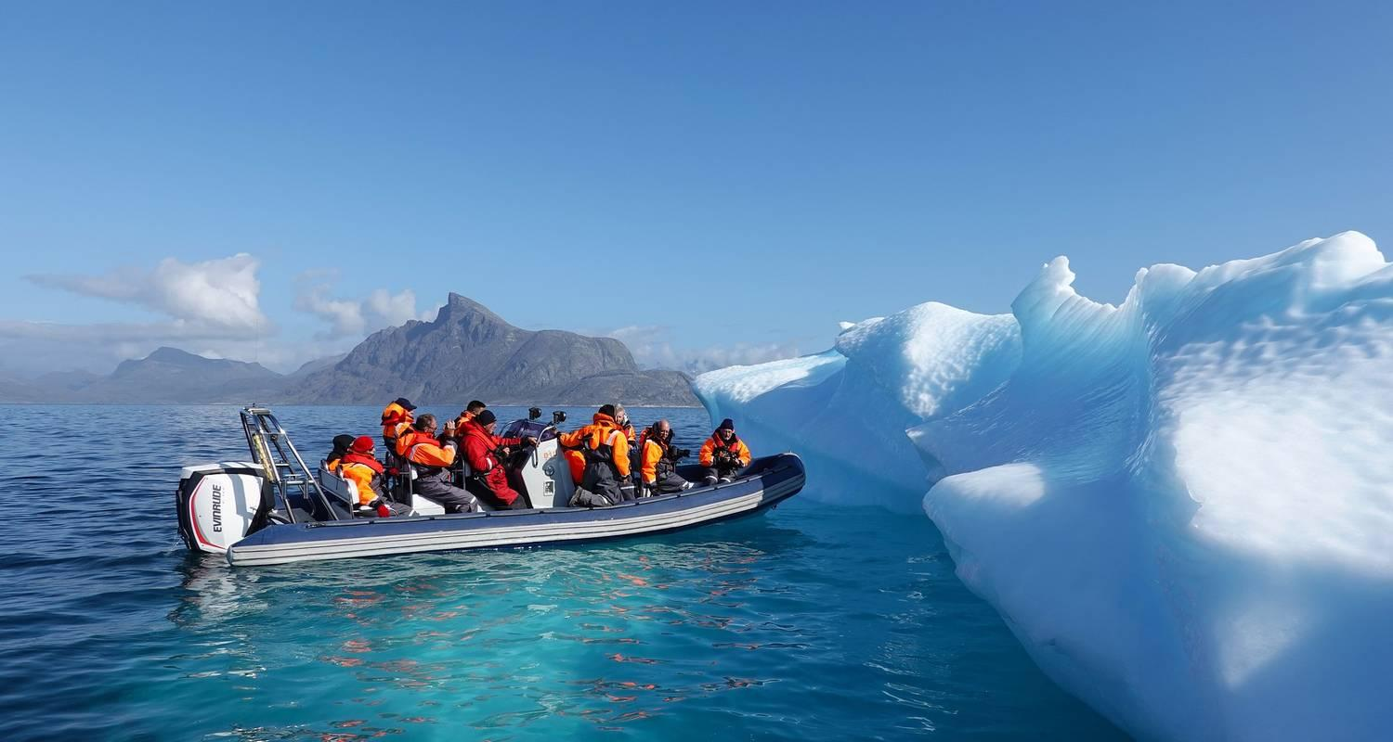

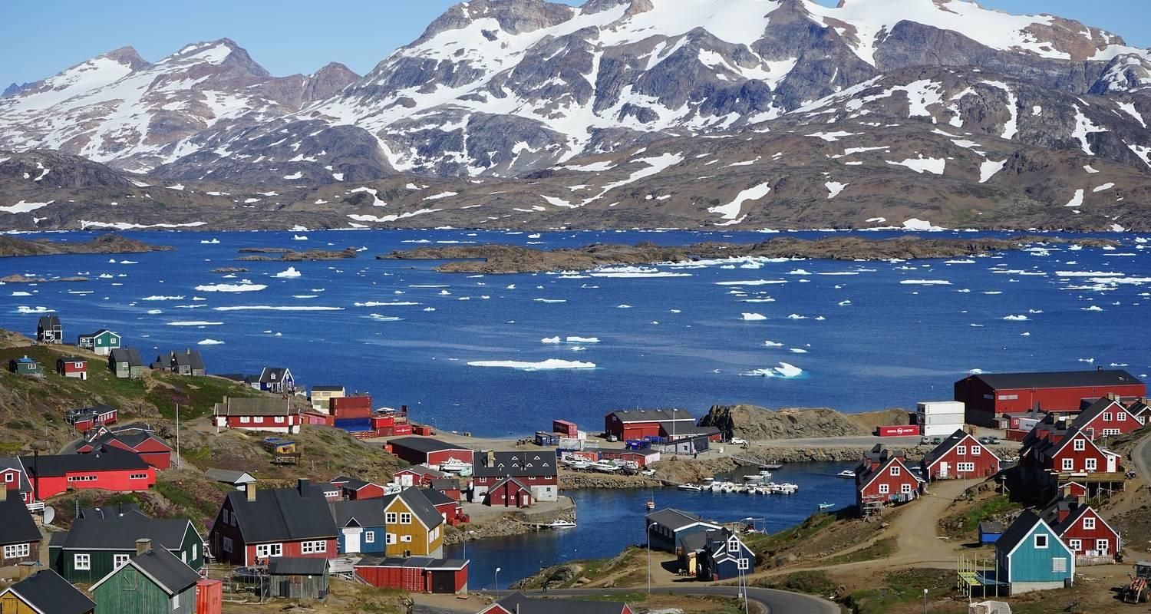

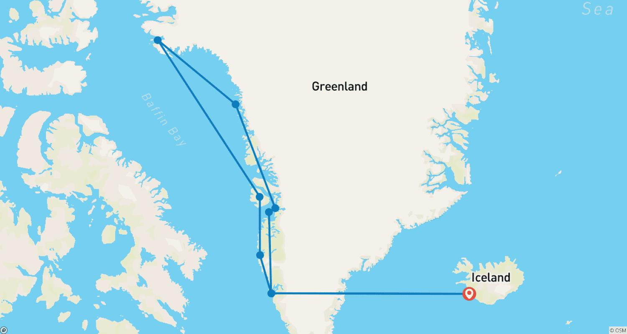

Tour ID: 265938  
Tour Name: Grand Greenland – Farthest North to Thule and Kane Basin

Tour destinations: ['Reykjavik', 'Nuuk', 'Disko Bay', 'Ilulissat', 'Uummannaq', 'Thule', 'Sisimiut']

Tour destinations images:











